Correcting Excessive overbites with V-Bend Activations of Super Elastic Wires; a New Technique
BY
SUHAIL A. KHOURI, D.D.S., ABO
CHESTERFILD, MO, USA

Traditional techniques correcting overbite features in all malocclusions have been known to be quite complicated, and challenging to orthodontists. Strong mechanical background, sophisticated appliance designs, diligent patient’s cooperation and multiple adjustment visits over a long treatment time are crucial elements for successful treatment prognosis of this dento-alveolar deformity. Despite the overwhelming advances that already modernized many orthodontic concepts, techniques, and practice, nonetheless modalities correcting overbites did not witness significant advances.
To date super elastic wires have been principally used only in their straight prefabricated form for the sole purpose of initial teeth leveling, until the Bendistal Pliers demonstrated their unique ability to cinch-back and bend NiTi wires, for the first time [1]. The possibility of placing permanent V-bends on super elastic archwires intraorally armed orthodontists with full control of super elastic wires and resurrected their advanced mechanical properties that were overlooked after performing initial teeth alignment. These bends provided instant techniques to employ their favorable light and consistent force delivery to effectively move groups of teeth in both transverse and vertical planes of space.
Clinical application of this concept has resulted in evolution of new techniques that showed efficiency in correcting a multitude of major orthodontic dentoalveolar deformities with unprecedented simplicity, convenience and time saving.[2]. This article elaborates on one new technique that corrects dental and skeletal deep overbite mostly featured in Class I and Class II malocclusions using simple routine wire adjustments during patient’s regular visits.

Literature Review
Orthodontic literature had described myriad approaches for overbite correction. Some approaches used fabricated loops, helices and springs made of stainless steel wires to create the bite-opening force system [3, 10-14]. Other ones used functional appliances with and without headgears.[4, 5]; while severe skeletal cases were managed with surgical approaches.[6-9].
Ever since the inception of their use in orthodontic practice, impossibility of bending super elastic archwires has restricted orthodontists to use them only in their prefabricated straight arch forms in initial teeth leveling. Subsequently they couldn’t use the superior elasticity of those wires in other orthodontic tooth movements. They could not even bend distal ends of such wires without annealing that ruins the entire wire’s resiliency and defeats the only purpose of their use. Many researchers demonstrated the validity of using intrusion appliances, helices and springs made of super elastic wires in their prefabricated forms[15-17]. Despite this success, however, the inability to bend these wires made it impossible to customize the costly intrusion appliances, and resulted in limiting the use of prefabricated elastic appliances and even wires.
Bending titanium wires without annealing or breakage requires specially designed pliers. Khouri developed one such set of pliers – Bendistal Pliers and subsequently showed how clinicians could use them for many intraoral sundry super elastic wire activations that moved segments of teeth and corrected overbites, crossbites, expanded and constricted dental arches, tip backs and rotate molars.[2]
The mechanical principles underlying bite opening techniques have been well-established and appreciated. in literature[3, 16, 19, 20]. Dake and Sinclair[13] reported that intrusions and extrusions achieved by both Ricketts and modified Tweed techniques remained stable. Hans et al[18] compared the efficiency of the headgear and bionator with fixed appliances in bite opening and found that both approaches produced incisor intrusion combined with skeletal mandibular changes that contributed to the correction of deep overbites. Burstone[3] has advocated that not all patients with overbites require incisor intrusion exclusively, rather some require posterior teeth extrusion to open their bite. He presented upright intrusion springs that intrude anterior teeth with minimal effect on posterior teeth. He recommended spring appliances with low load/deflection rates to produce the optimal intrusive forces. Sander et al[16] described intrusion mechanics completed with NiTi uprighting springs with low load / deflection rates that could intrude incisors a magnitude of 7mm.
Shroff et al[11] found it difficult to correct deep overbites when accompanied with flared incisors by conventional orthodontic therapies. They subsequently recommended the Burstone segmented arch approach for achieving precise vertical and horizontal simultaneous movements of teeth. Davidovitch and Rebella[12] described an intrusion archwire that uses only tip back bends close to molars, to achieve bite opening. Nanda has also described appliance systems and biomechanical techniques for incisor intrusion. Melsen et al[15] compared force systems generated by stainless steel and beta titanium cantilevers with helices and have demonstrated that quality of the wire influences the relative stiffness. They showed how various laboratory wire configurations could deliver predetermined horizontal and vertical forces.
Using the V- bends in bite opening mechanics and other mass tooth movements’ is not new and was successfully used on manufacturer-bent super elastic wires by researchers[13,15,21,22].
What makes this technique more clinically applicable however is the orthodontist’s ability to customize the exact orientation, locations and easy placement of permanent V-bends intraorally on tied super elastic wires with the proper tool during their patient’s routine adjustment visits.

Material and Method
The pliers used to place the intraoral V-bends on NiTi wires in this technique are new pliers called Bendistal Pliers (Figure 1 A,B). They are designed longer and thinner than conventional ones, for easier accessibility in the patient buccal sulcus. They are made in a set of two pliers – one for the archwire adjustments in maxillary right and mandibular left quadrants, while the other pair makes adjustments in maxillary left and mandibular right quadrants

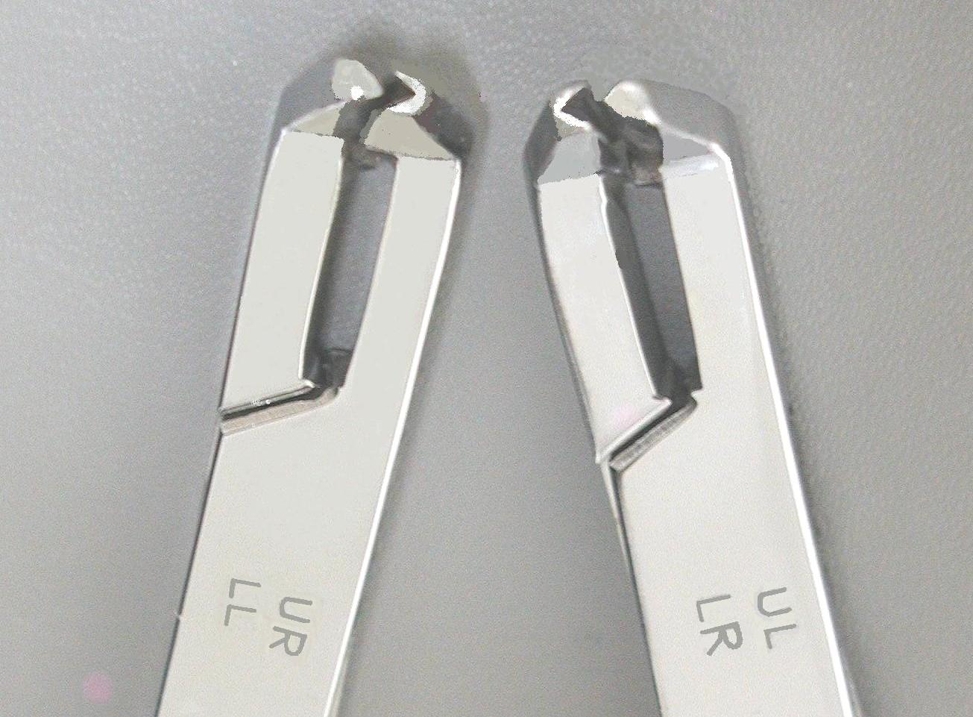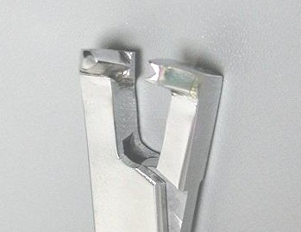
GINGIVAL
JAW
OCCLUSAL JAW
A
B

Figure.1. A. Front View of Bendistal Pliers showing engraved letter abbreviations of the two quadrants each pair of pliers serves. B. Enlarged view of the pliers jaws that serve maxillary right and mandibular left quadrants.

A full squeeze of the pliers jaws around the archwire creates a permanent sharp bend on most types and sizes of super elastic wires extraorally and intraorally without annealing or fracture (Figure 2. a & b). The resulting bend angle is slightly obtuse and ranges between 100-110 degrees. The stability of the obtuse bend angle protects the titanium archwire against fatigue or fracture after tying, and maintains an efficient and consistent level of light force delivery.
Placing such V-bends has expanded the scope of clinical usefulness of super elastic wires far beyond the preliminary alignment and rotational control of teeth they primarily do. They activate such wires to move single or whole segments of teeth in vertical and horizontal planes to correct many dento-alveolar deformities with unsurpassed simplicity and dispatch. This article is focused on the vertically oriented V-bends that help open severe overbites.

Making the V-Bends
To place the bite opening V-bends on maxillary archwire, position the apex of gingival jaw of Bendistal Pliers above the archwire, with the occlusal jaw underneath it as shown in figure 2, a. For bite opening V-bends on mandibular archwire, position the apex of the gingival jaw below the archwire and the occlusal jaw above the archwire as illustrated in figures 2, b. Then make a firm squeeze in the recommended locations on the archwire.

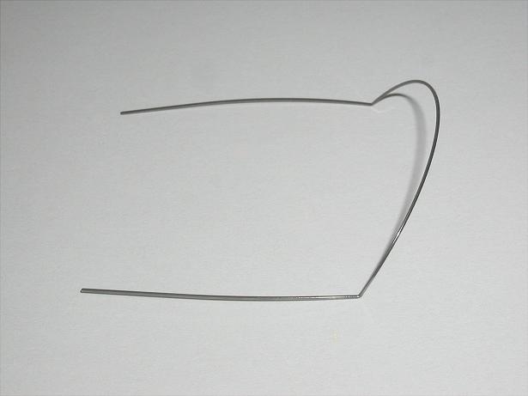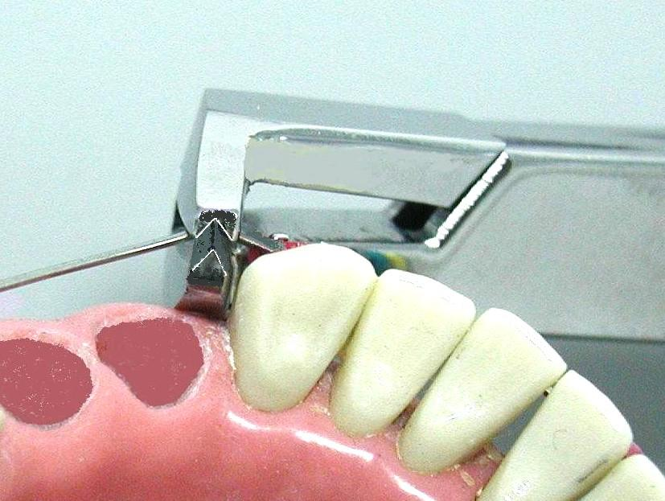
GINGIVAL JAW
OCCLUSAL JAW
A
B
Figure 2, A Permanent 110 degree intrusive bends on a maxillary NiTi wire 0.016”x 0.22” placed extraorally distal to canine’s areas. B, placing Intrusive bend on mandibular archwire is done by reversing plier’s jaws.

Before using the pliers, clinicians must be familiar with the most effective orientation, location, and direction of each V-bend on archwire that activate it to create the prescribed force system prescribed to elicit the planned teeth movement. Also the proper positioning of the pliers jaws in relation to the archwire, is equally critical to place the proper bends and to master the technique. Precision in orienting the apex of the V- bend on an archwires determines whether the teeth will intrude or extrude. To intrude maxillary incisors, place pliers jaws as shown in (figure 2 a), and to intrude lower incisors place pliers jaws as shown in (figure 2. B) and vise versa.

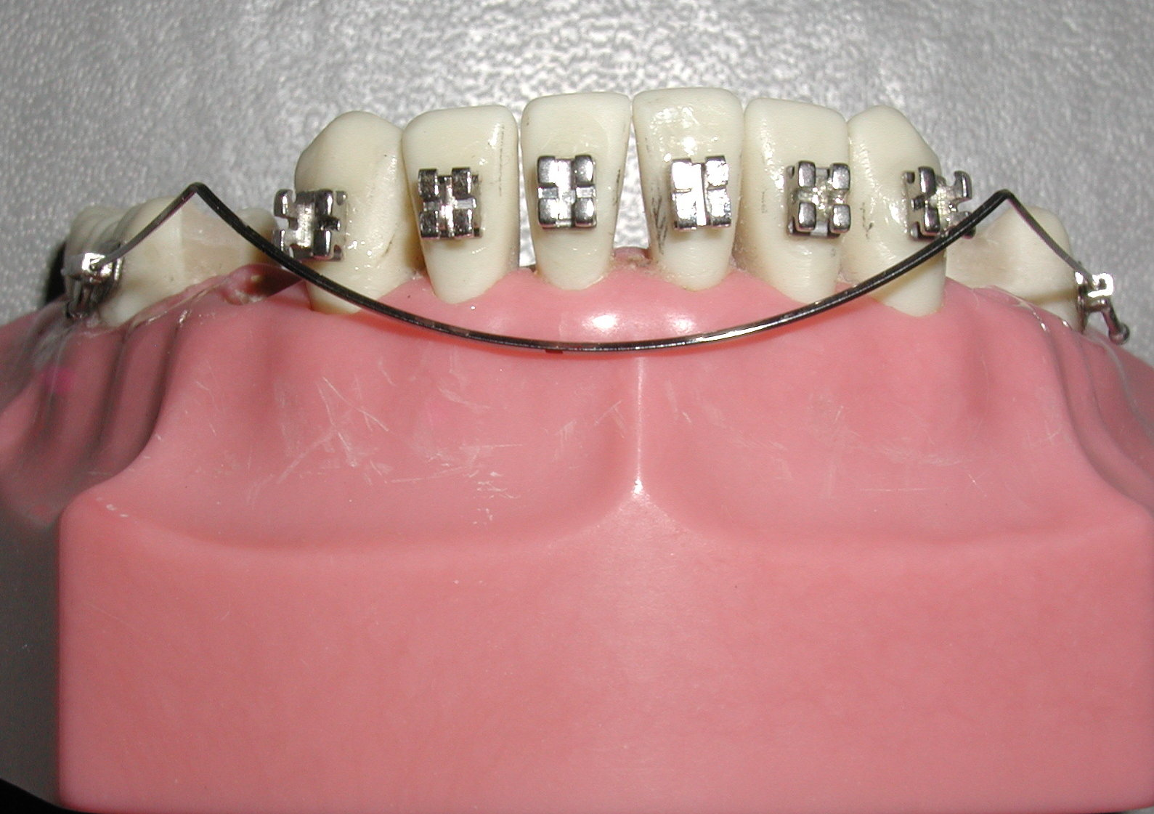
A
Figure, 3, A, illustrates the long range of wire activation after placing the V bends on 0.016”X0.022” NiTi archwire.Those bends can be easily placed either extraorally or intraorally in the midway point between canine and first premolar brackets. Upon tying the active wire will deliver a consistent intrusive force and moment on anterior teeth segment - from canine to canine. The curvy shape of activated wire delineates the ultimate prospective incisors positions the wire will intrude them to.

Rationale of the New Technique
This technique was actually inspired by Bendistal Pliers ability to place lasting bends and activate tied super elastic archwires intraorally. Resiliency of super elastic wires provided light force delivery and allowed bending tied archwires without breaking adjacent brackets. Also the stability of bends ensures consistency of force delivery over the long range of activation those wires are famous for. The key to success of this technique is its simple clinical applicability, its convenience and time saving, besides enabling orthodontists to customize number and locations the intrusive V-bends on tied archwires.

Mechanical Considerations of the V- Bends
- It is well known that V-bend on any orthodontic wire create two moments equal in magnitude and opposite in directions acting on teeth in both sides of that bend (Figure 4A). The labially directed moment acting on teeth segment anterior to the V-bend is counter acted by an equal and posteriorly directed moment (side effect), on teeth segment posterior to that bend. Analyzing those moments to the couple of forces causing them, we see intrusion of the furthest teeth on both sides of the V-bend; and extrusion of teeth closest to that bend (Figure 4.B). Actually the intrusion effect and the extrusion side effect resulting from this V-bend technique both work favorably to open the deep overbite.
M1
M2
M1
M2
INTRUSION
INTRUSION
EXTRUION
M1
M2
M1
M2
INTRUSION
INTRUSION
EXTRUION
M1
M2
M1
M2
INTRUSION
INTRUSION
EXTRUION
A
B

INTRUSION
INTRUSION
EXTRUSION

Figure 4.A. Diagram showing analysis of the force system created by V-bends located between canine and first premolar. To bring the system into equilibrium, anterior moment M1 must be equal to posterior moment M2. B; Shows the intrusion and extrusion effects of both moments acting on tooth segments located on both sides of the bend.

- The apically directed forces applied through facial brackets of anterior teeth, intrude them and cause them to flare because the force line passes facial to their center of resistance creating a labially directed moment. Such flaring can be controlled with elastomeric power chain extending from one upper molar to the other.

- In maxillary 1st premolar extraction patients, posterior segment consisting of 1st molars and 2nd premolars provides an anchorage of 8 roots, to intrude the six roots of the anterior teeth segment. Posterior teeth anchorage can be further strengthened by adding both maxillary 2nd molars that increases number of anchor roots to 14, if minimizing the side effect is indicated. The anterior teeth intrusion is elicited by the vertical component of force of the anterior clockwise moment causing the bite to open. Clinician can decide whether to prevent or take advantage of the extrusive side effect on teeth close to both sides of the V-bend that help opening the deep overbite as well, figure 4.

- Although intrusion of the furthest molars of posterior segments may be an unwelcome side effect [23] however, it is very advantageous since the apically-directed force acting buccally to molar’s center of resistance, intrudes their buccal cusps and extrudes their lingual cusps. This very side effect becomes a favorable indispensable step to disengage upper and lower molar cusps that simplifies cross-bite correction by routine bend adjustments. It actually constitutes the core of the rationale for another technique to correct cross bites. This technique will be addressed in a future article.

Clinical Technique and Wire Sequence
Traditional intrusive appliance designs and springs made of stainless steel wires required long prefabrication time, frequent adjustments, and high patient cooperation over long treatment time. Although V-bends on stainless steel wires were already known to intrude teeth, however their relative stiffness and short range of activation limited their efficiency and clinical application.
On the other hand, using Bendistal Pliers makes it clinically simple and possible to place V-bends on titanium archwires ensuring light and consistent intrusive force delivery. To master this technique, orthodontists must have good background in creating the bite opening force system through placing V-bends that incidentally conform to segmental formats.
This technique can be started as early as the initial small-sized 0.016” NiTi wire finish its sole role in preliminary teeth alignment. Instead of discarding this wire, placing V- bends on it distal to both canines rejuvenate this wire and take its performance to a much higher level as shown in figure 4. Once the bite opens enough to allow mandibular incisor bonding, a similar small sized NiTi wire is tied in to align mandibular teeth and possibly start early intrusive bends on mandibular archwire. Then the light magnitude of the intrusive force on anterior teeth can be increased according to case severity, by upgrading wire size, to a thicker rectangular one. (Figure 5)

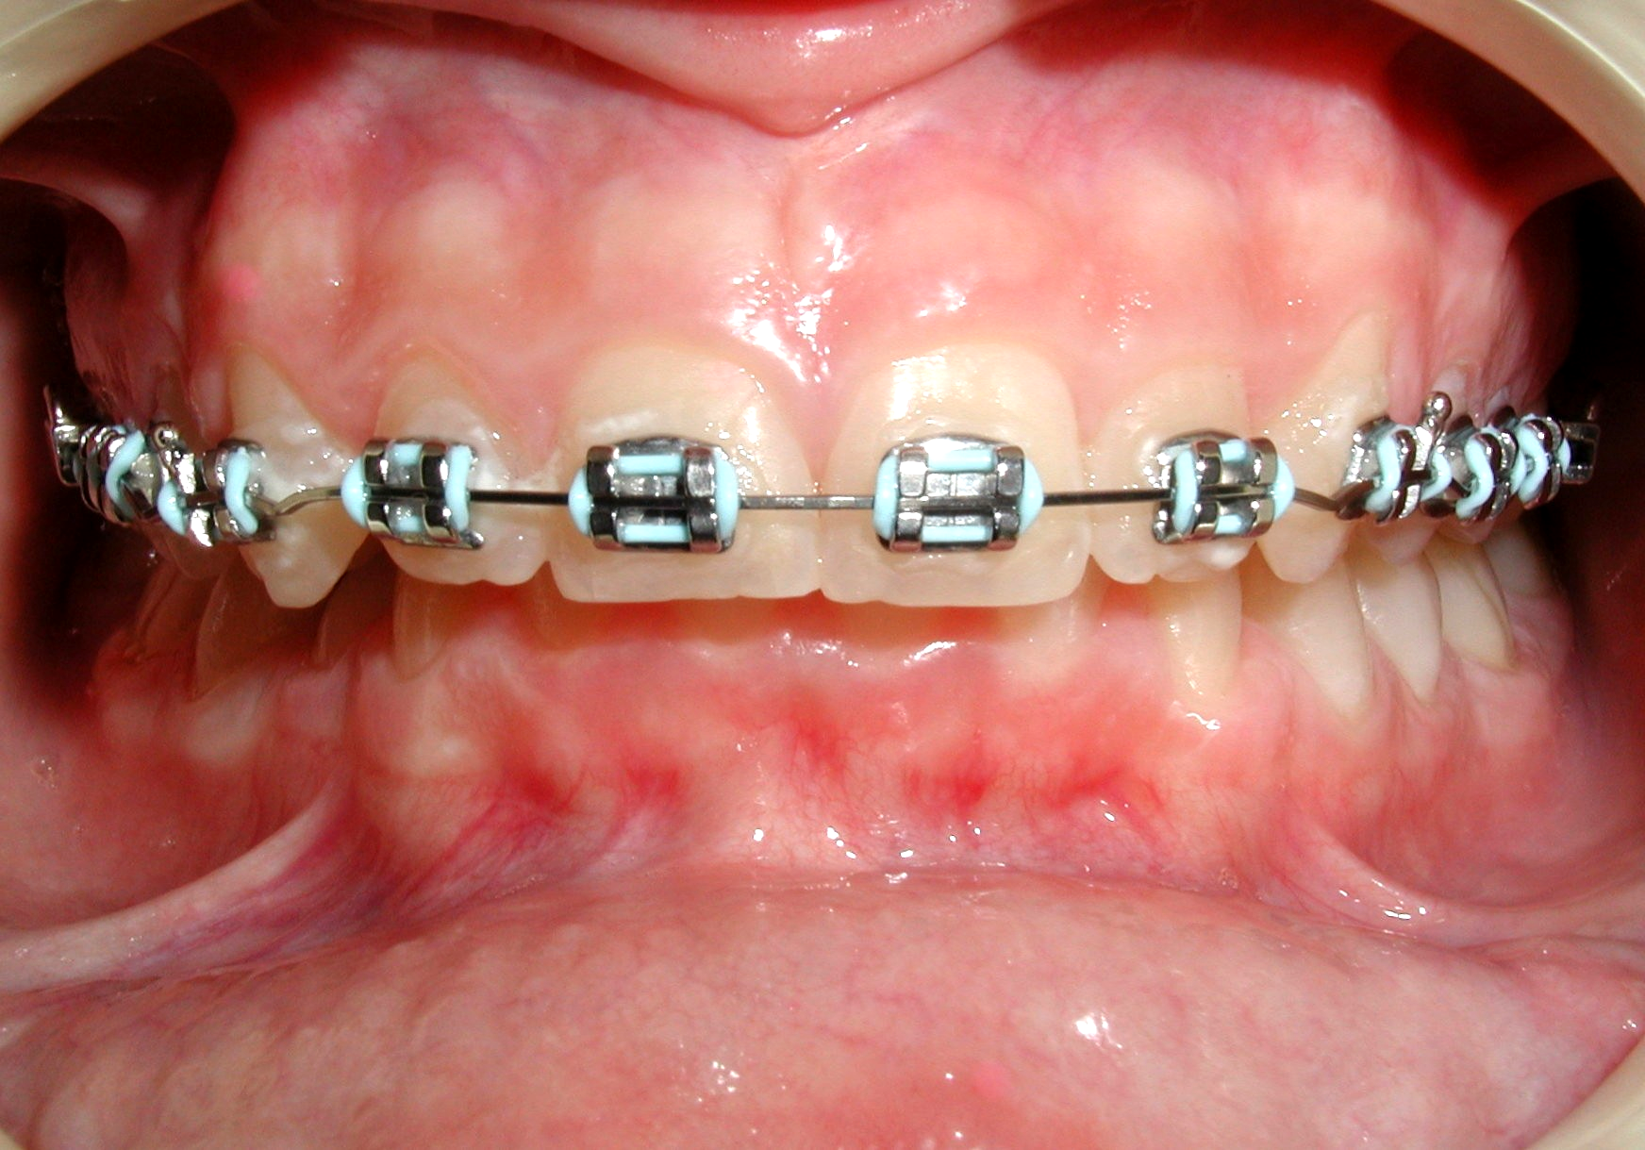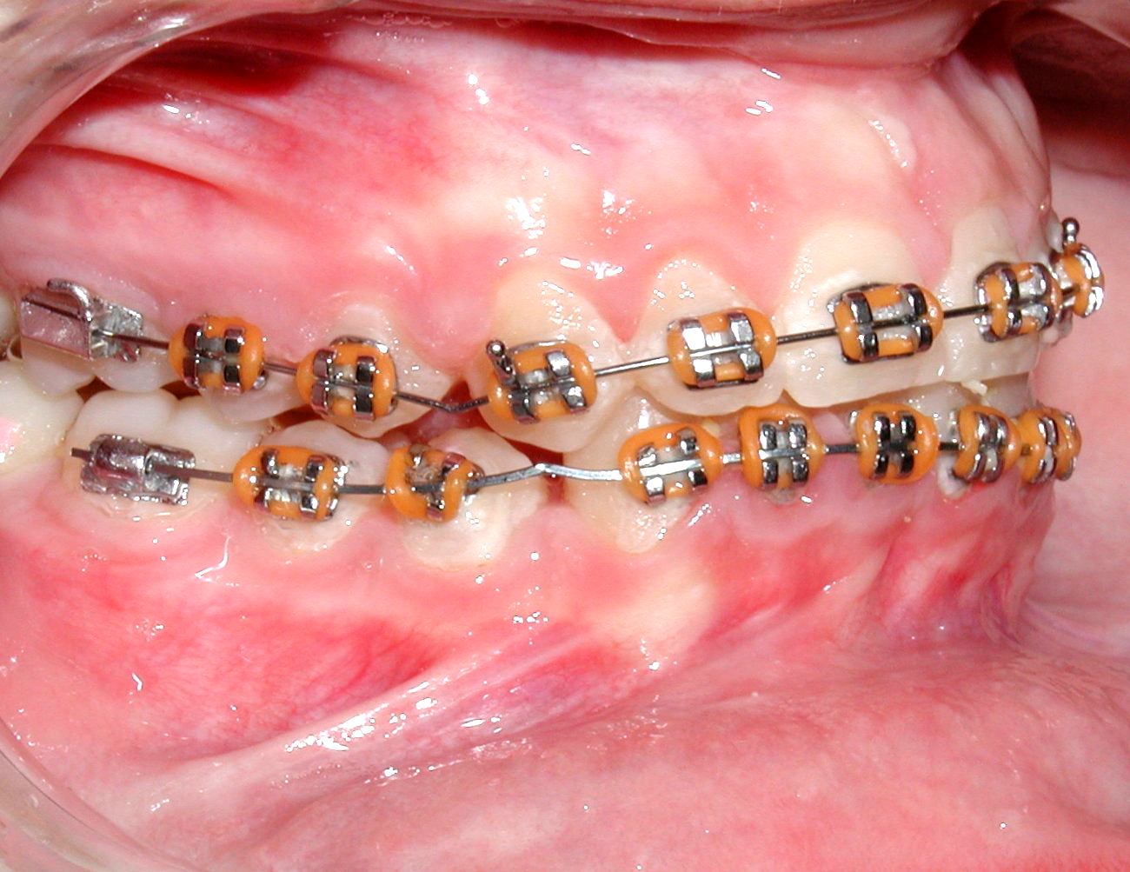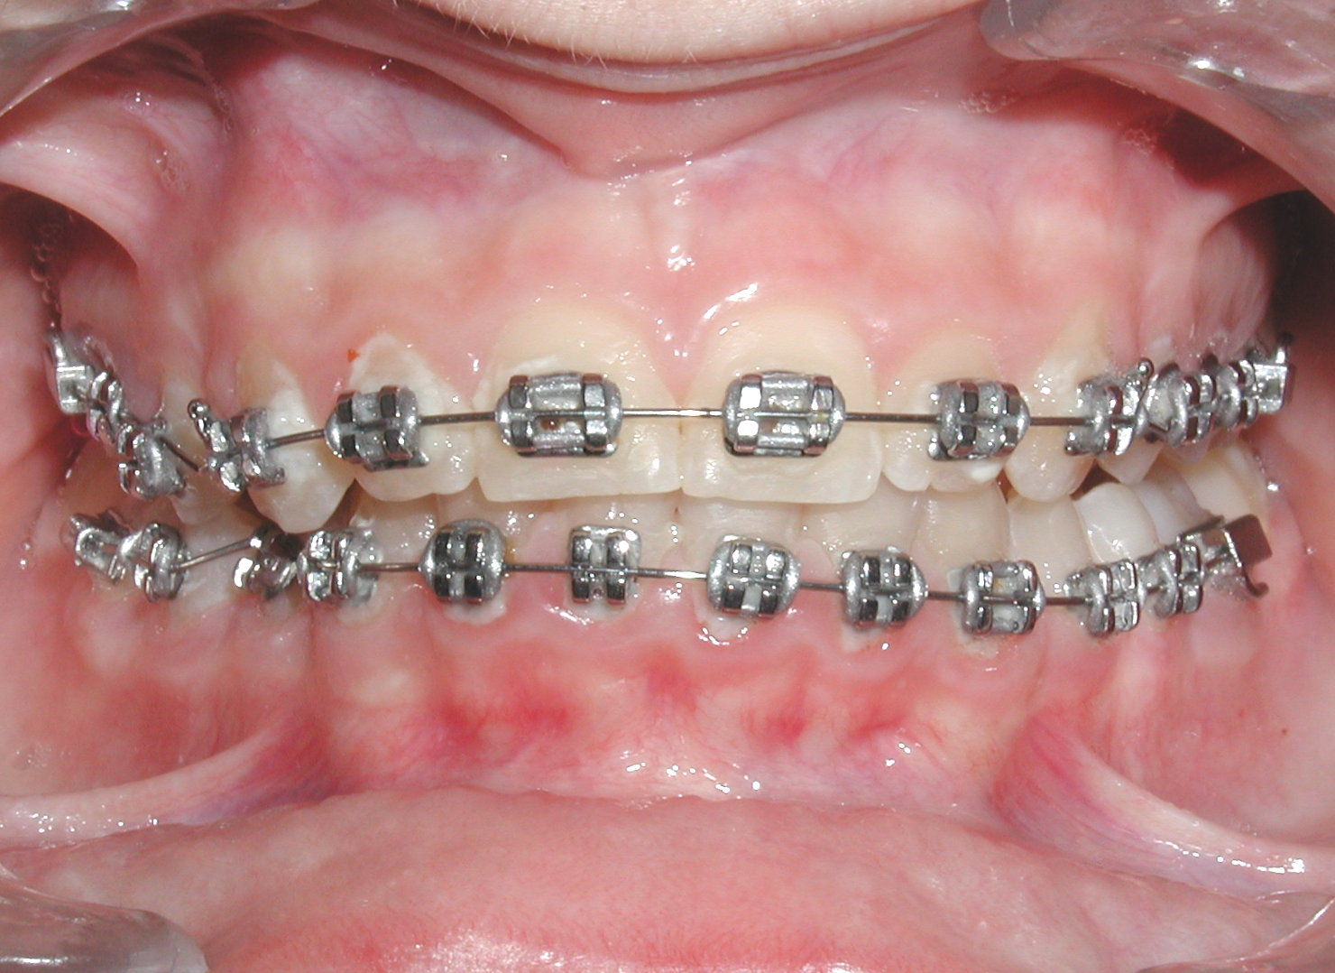
B
A
C

Figure 5 A. Intraoral frontal view of a skeletal overbite overjet of Class 11 Div.1. B., Lateral intraoral view of a the same patient half way through bite-opening process, and the intrusive V-bends on 0.016”X0.022” NiTi distal to canines (arrows) on both archwires. Note how once maxillary incisors are intruded enough to bond mandibular teeth how mandibular archwire with reversed V-bends on it helped opening the bite. C., Frontal intraoral view showing the bite opening effects of V- bends on maxillary and mandibular arches in an advanced stage of treatment.

If overbites extend more that 100%, greater force is required to intrude anterior teeth. V-bends on larger size rectangular NiTi wires (.016 x .022), deliver relatively greater and consistent force that is still tolerable by patients and not so stiff to break the neighboring teeth brackets.
As the mandibular teeth align and the mandibular curve of Spee starts to flatten, replace the initial wire with a .016 x .022 NiTi archwire to get a greater force magnitude by placing similar V-bends in the same locations on it. Monitor the case for few months until the overbite opens. In cooperative patients overbite is corrected in about six months.
In later stages of treatment, if greater force is required, stainless steel rectangular wire may be used with similar V bends to over correct or/and maintain results. A very gentle or incomplete squeeze of the plier’s jaws is adequate to activate stainless steel wires to deliver a greater intrusive force without breaking adjacent brackets.
Patients who display severe skeletal overbites (150% or more), will benefit from acrylic bite plates that will allow early and simultaneous mandibular incisor bonding and commencement of intrusion mechanics on both dental arches (figure 6). Simultaneous bonding both arches shortens bite opening time. The same wire sequence and activation is followed in mandibular arch as that in maxillary one.
B
C
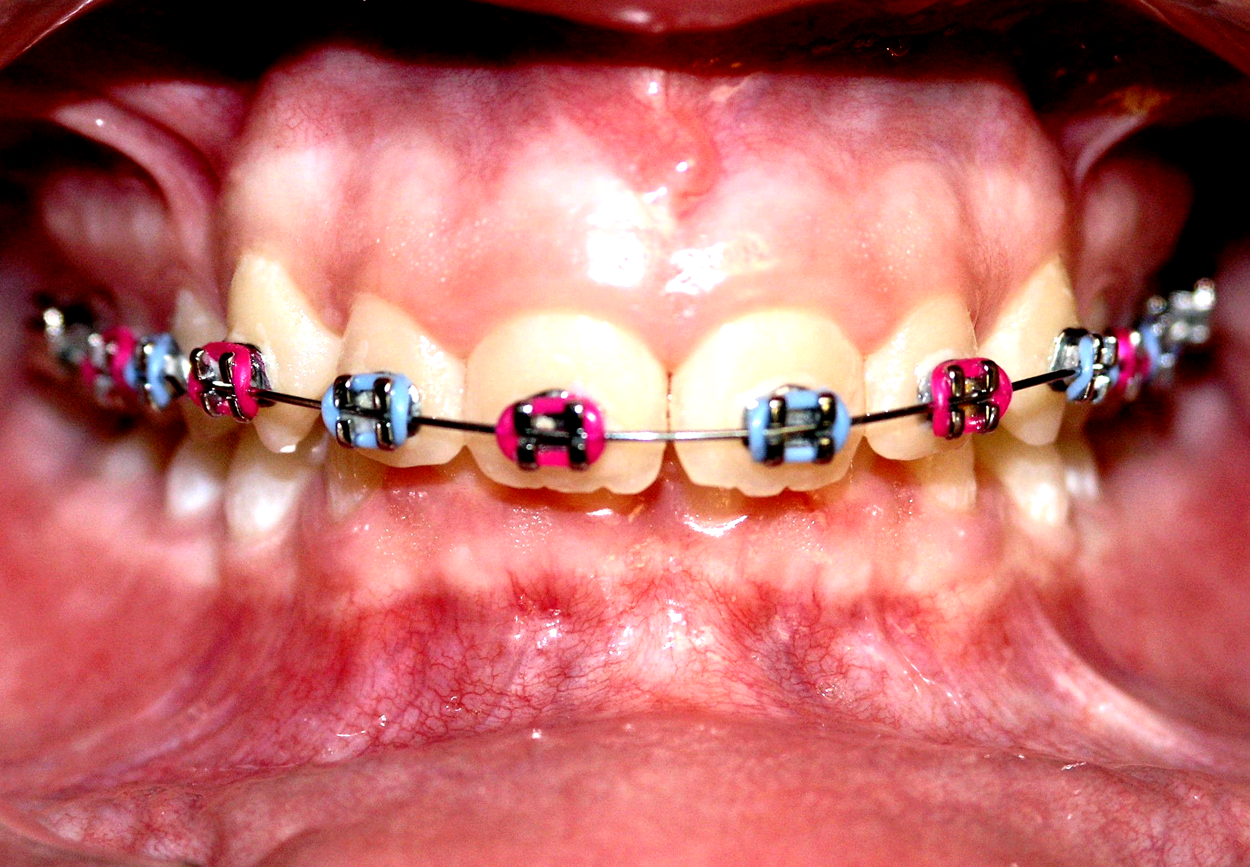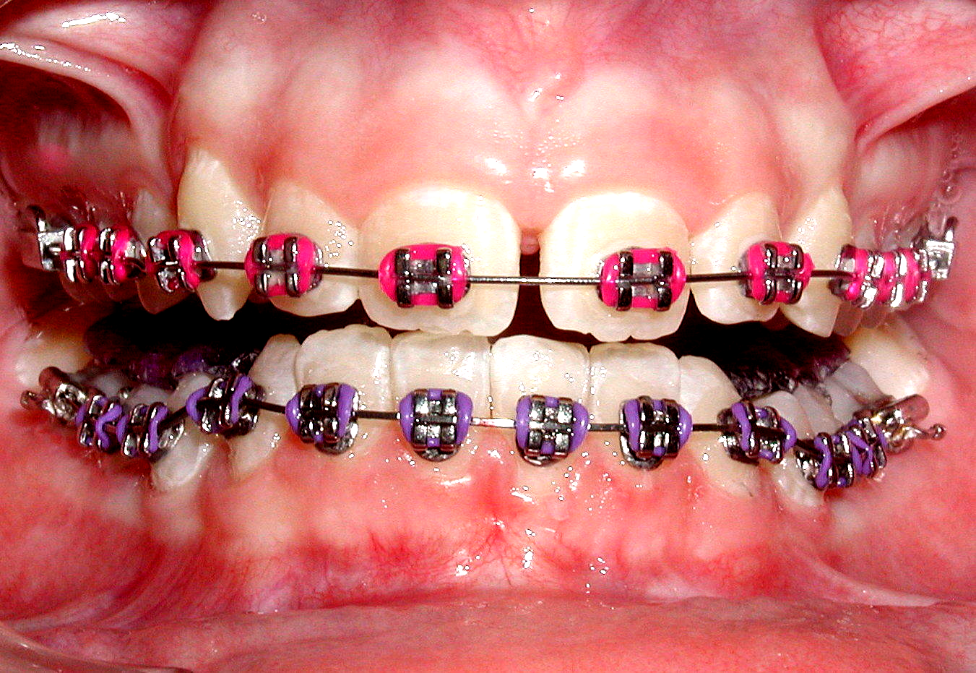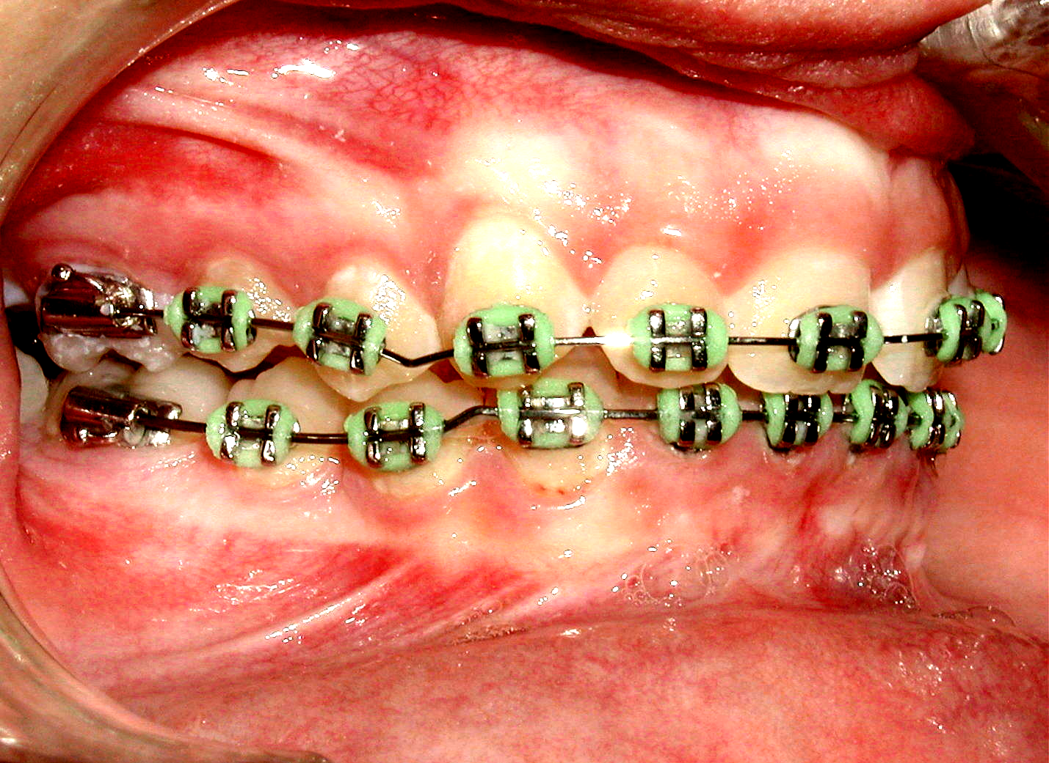
A
Figure 6.A, Frontal intraoral photograph of a Class II division 2 patient with more than 100%severe overbite that prevented mandibular incisors bonding. B. Same patient with a blue bite-raising plate in place (arrow), allowing mandibular teeth bonding and simultaneous placement of mandibular initial aligning archwires. C. Right intraoral view during treatment showing the bite-opening effect of the upper and lower V-bends (arrows) on 0.016” X 0.022” NiTi archwires that allowed safe removal of the acrylic bite plate and continuation of treatment.
Once overbite opens enough to allow mandibular incisors bonding, remove the bite plate and leave the active wires for few more months until the normal 1-2 mm overbite relation is restored. Intrusive wires should not be left in mouth unsupervised for long months to avoid unnecessary over treatment. At this stage clinician can reposition mandibular incisor brackets more incisally where needed, (especially in cases where the brackets were placed gingivally to avoid occlusal interference). This step flattens mandibular curve of Spee and facilitates restoring and maintaining the normal overbite relation with just tying a straight wire. Rectangular finishing NiTi or stainless steel archwires without bends are recommended for this purpose. Should the need for additional bite opening develop during the finishing stage, half-squeeze bends on stainless steel wires or full squeezes on finishing NiTi wires ensures over correction.
Dealing with severe skeletal overbite that is complicated by excessive skeletal overjet in Class II division 1 patients, there is usually an adequate space allowing mandibular incisors bonding with or sometimes, without bite plate. Despite the severity of such cases, simultaneous commencement of bite-opening mechanics on maxillary and mandibular arches along with maxillary anterior teeth retraction that should have been planned and executed concurrently; bring about a fast treatment result (Figure 7).
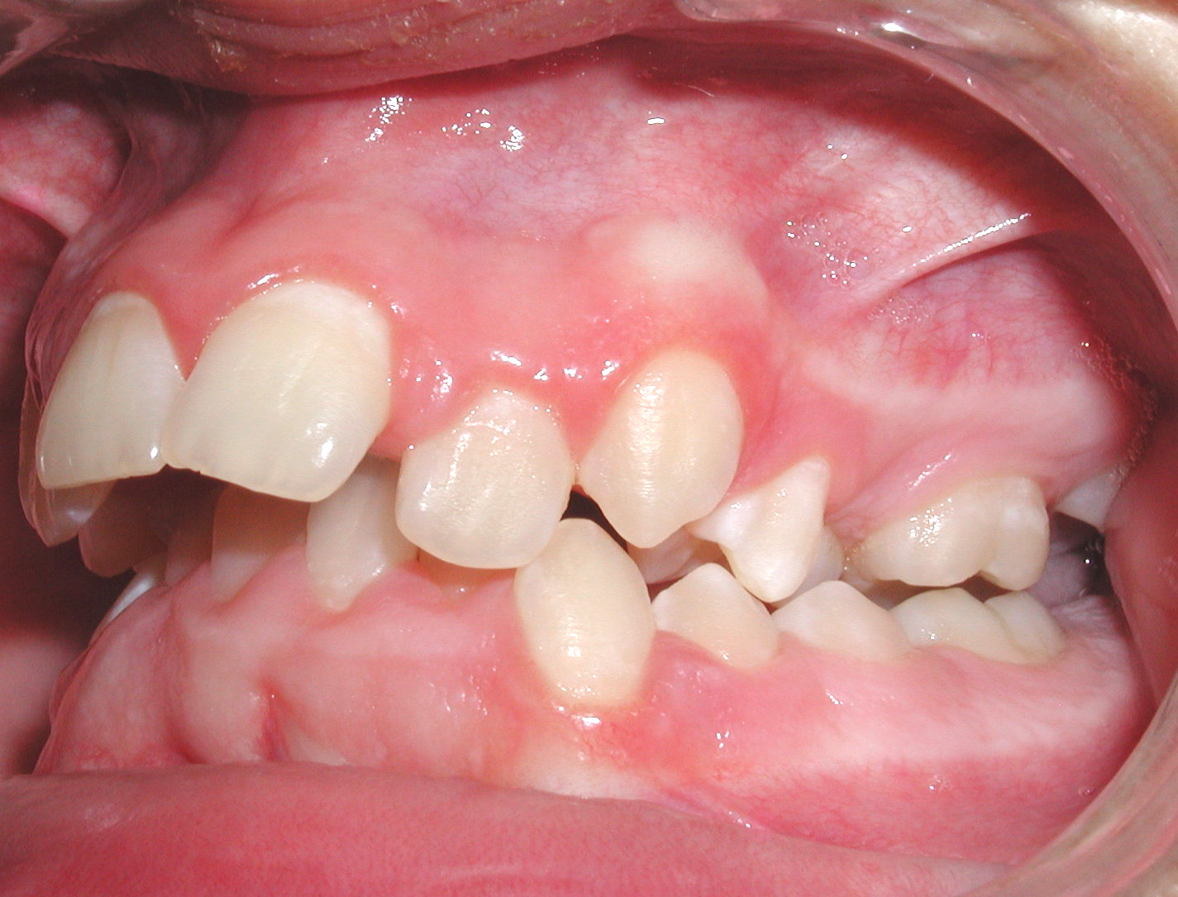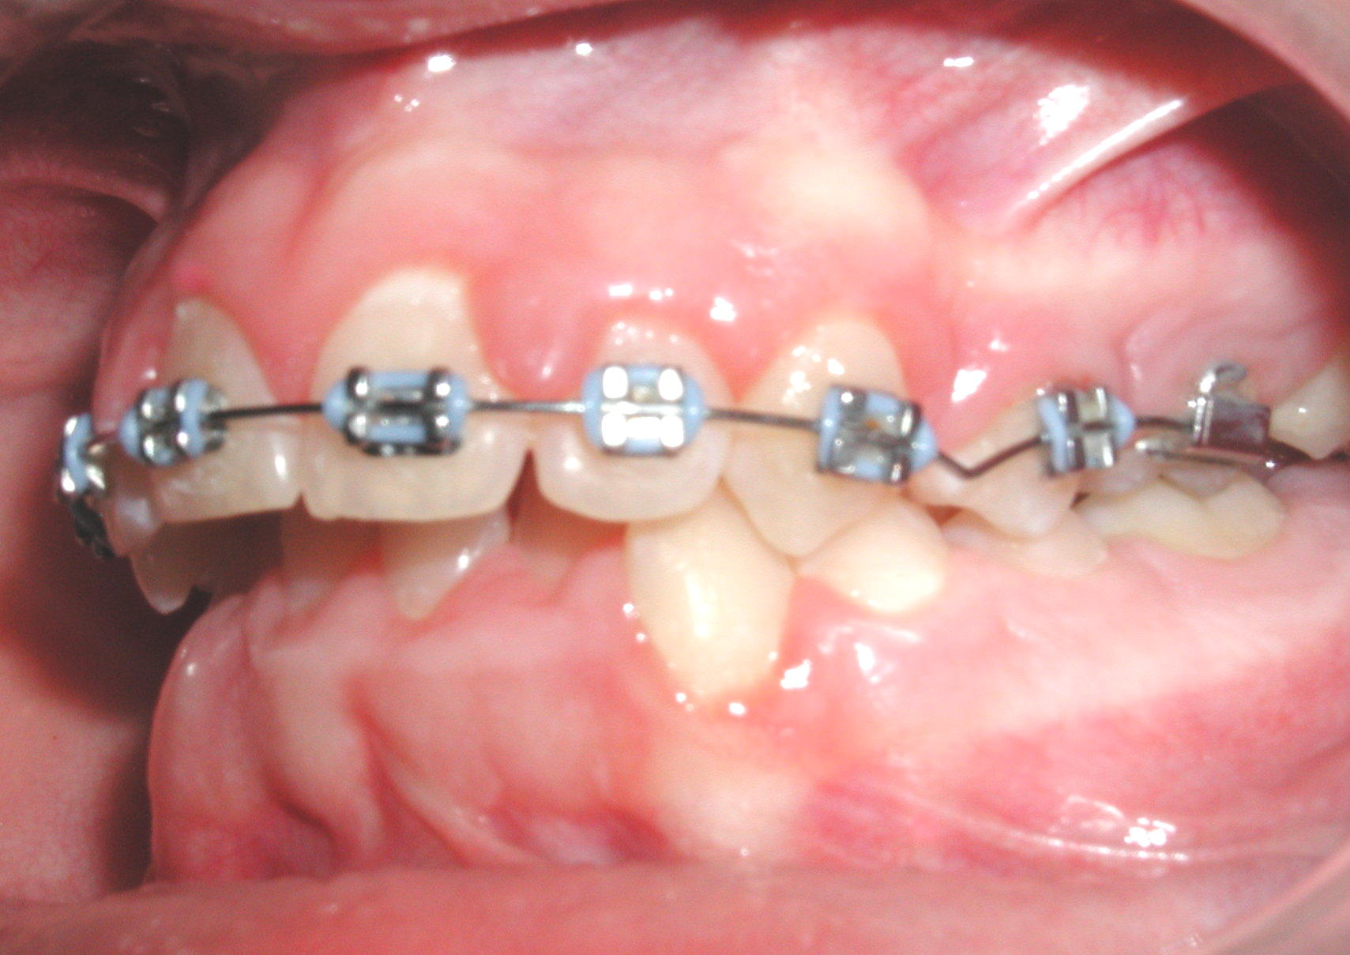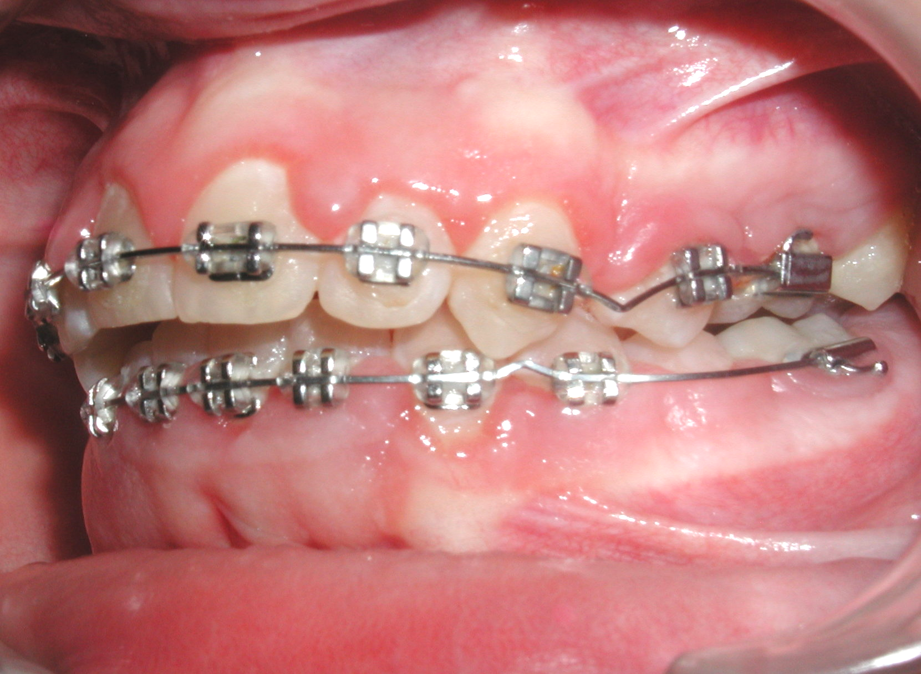
A
B
C
Figure 7, A Pretreatment lateral intraoral photograph of a severe over bite, complicated by excessive overjet in a Class II Division 1 patient. B. The excessive overjet allowed easier mandibular teeth bonding that helped tying an initial and later on intrusive mandibular archwire. C., Shows mandibular teeth leveling and bite opening effects of the V-bends in on both archwires. Note flattening of mandibular curve of Spee and location of V- bends on both archwires that brought about this progressive result with and after anterior teeth retraction.
A
B
C
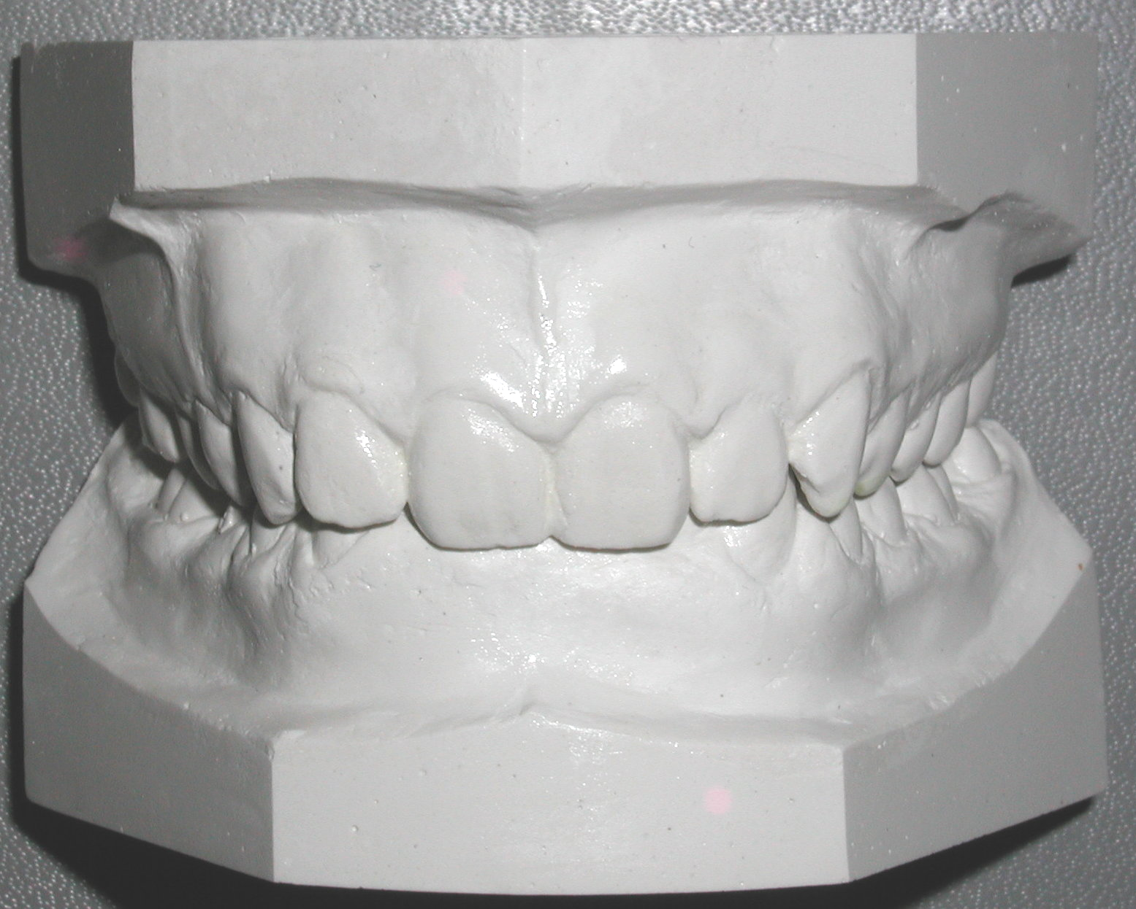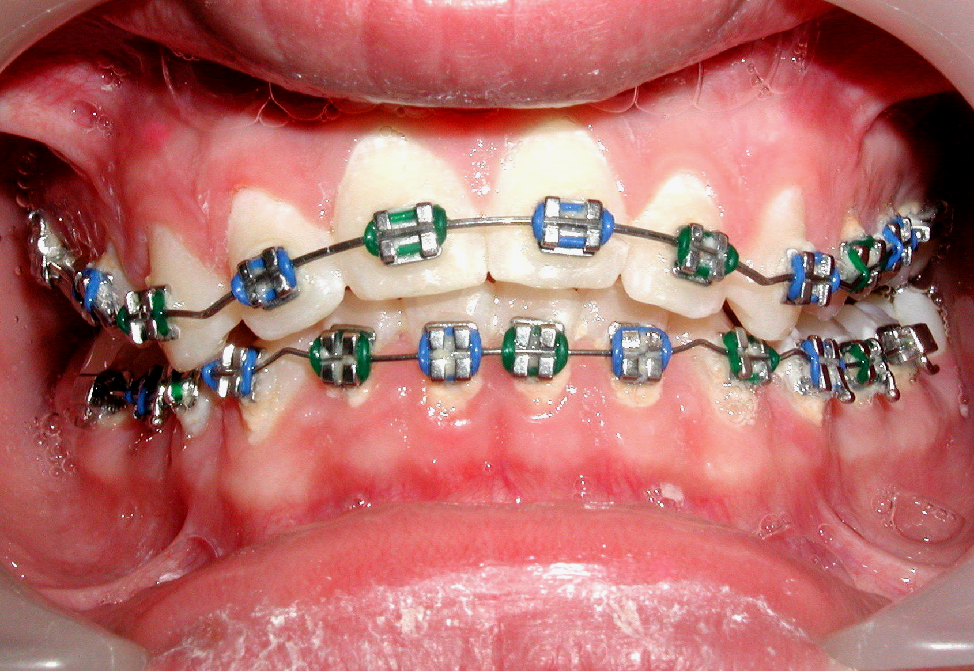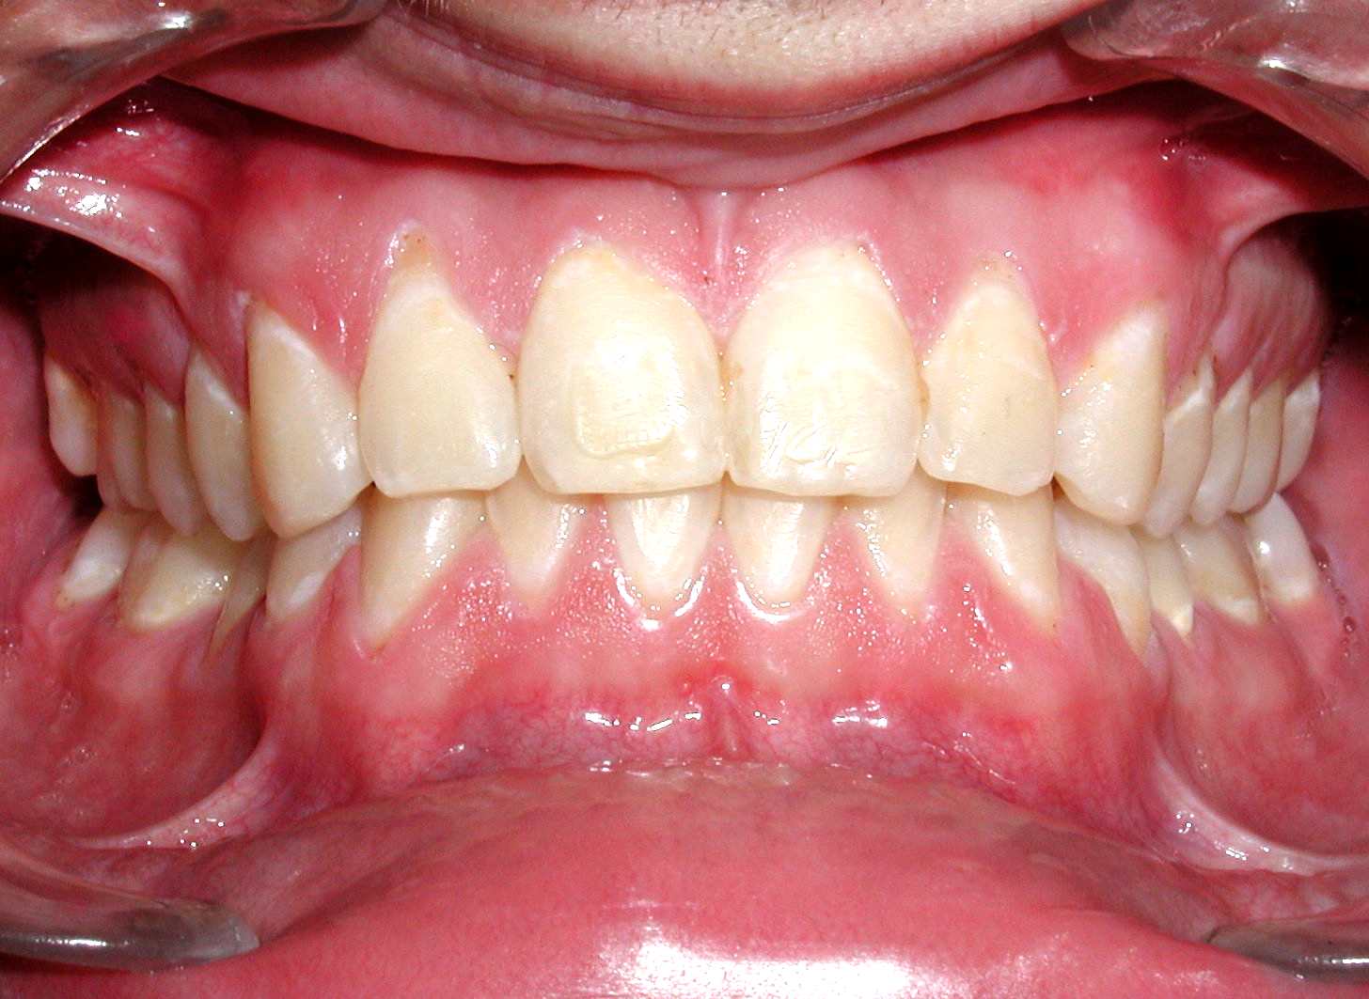
Figure 8.A, Pretreatment models showing excessive overbite in a Class II, division 2 patient. B shows the orthodontic effect of V-bend’s bite–opening mechanics in both arches. Note locations of additional V-bends distal to lateral incisors on maxillary and mandibular 0.016”X0.22” NiTi archwires (arrows), that brought about this effect. C, Shows post-treatment frontal intraoral photograph of the same patient.

Patient Treatments
Following are cases with severe overbites treated by this V-bend technique.
.
C
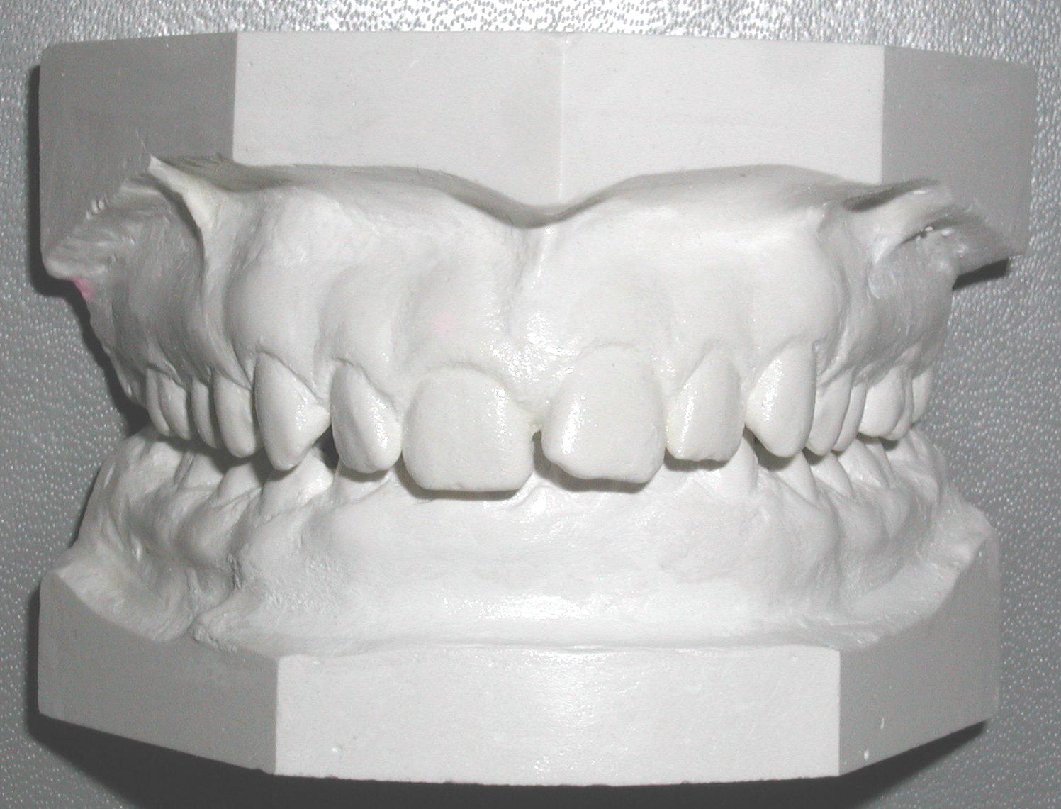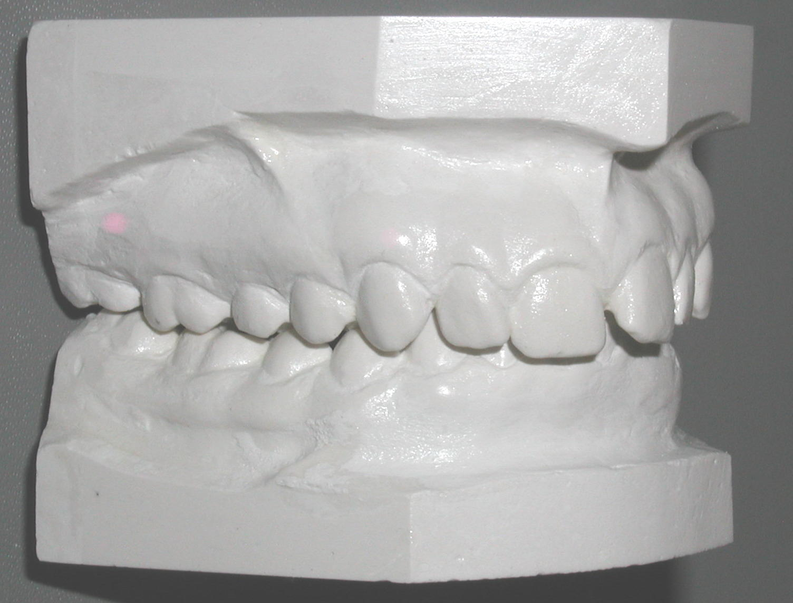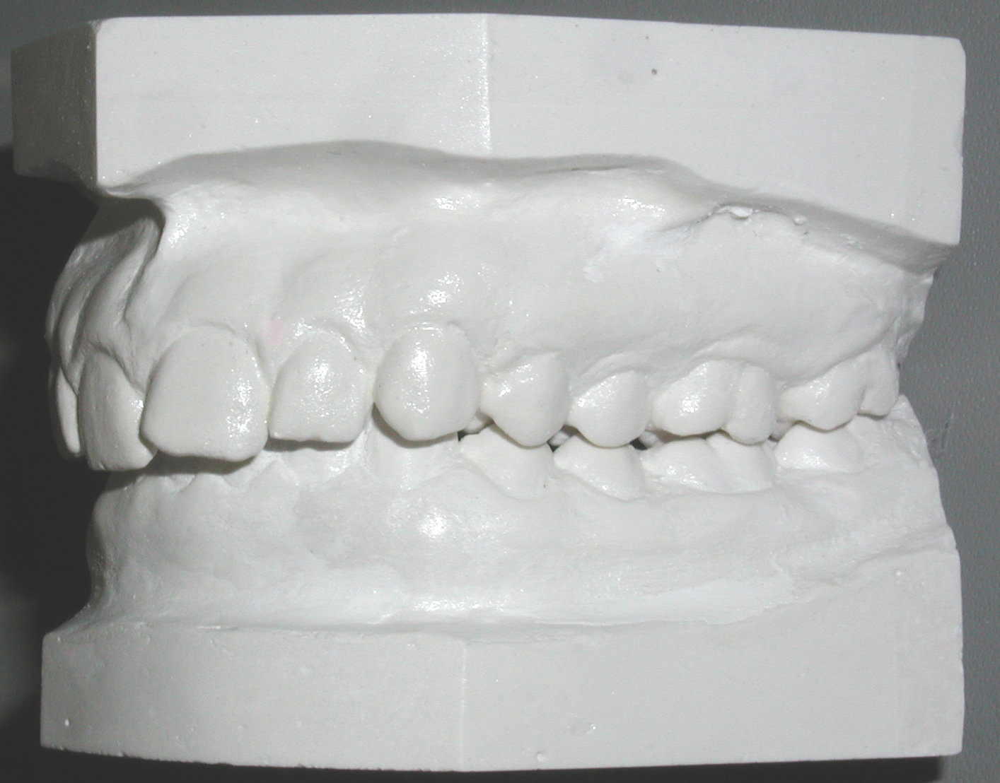
C
A
B
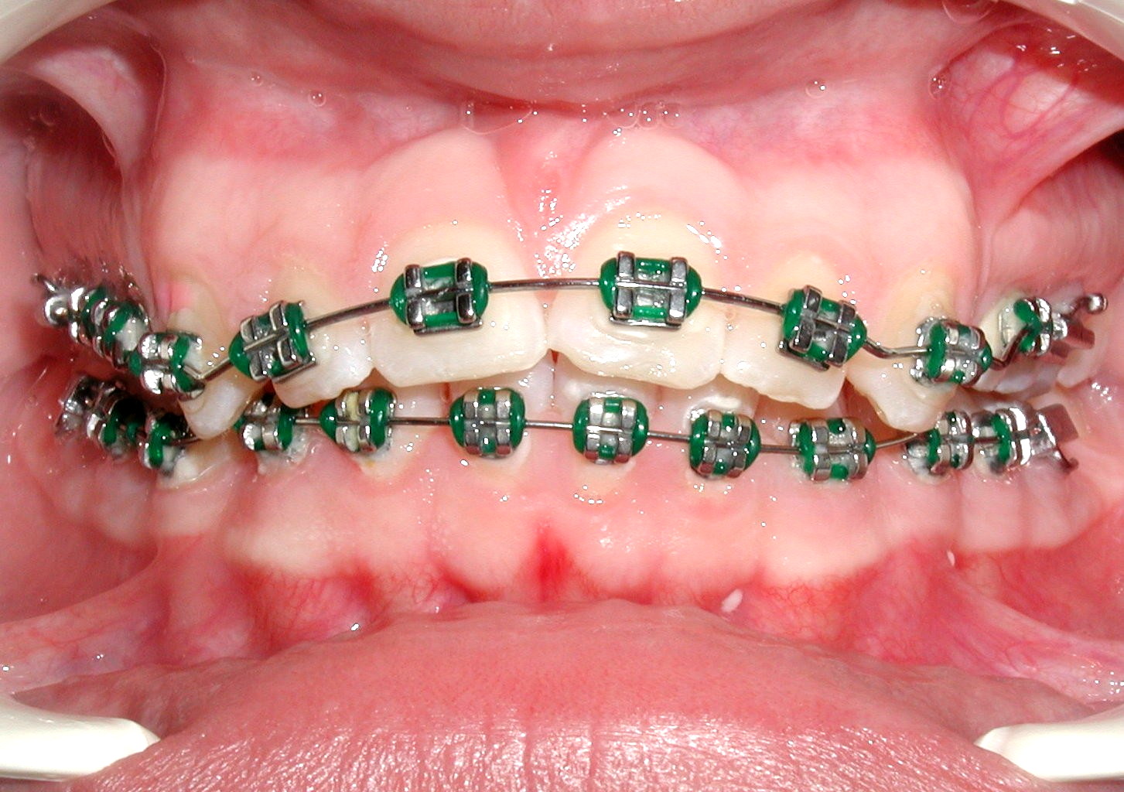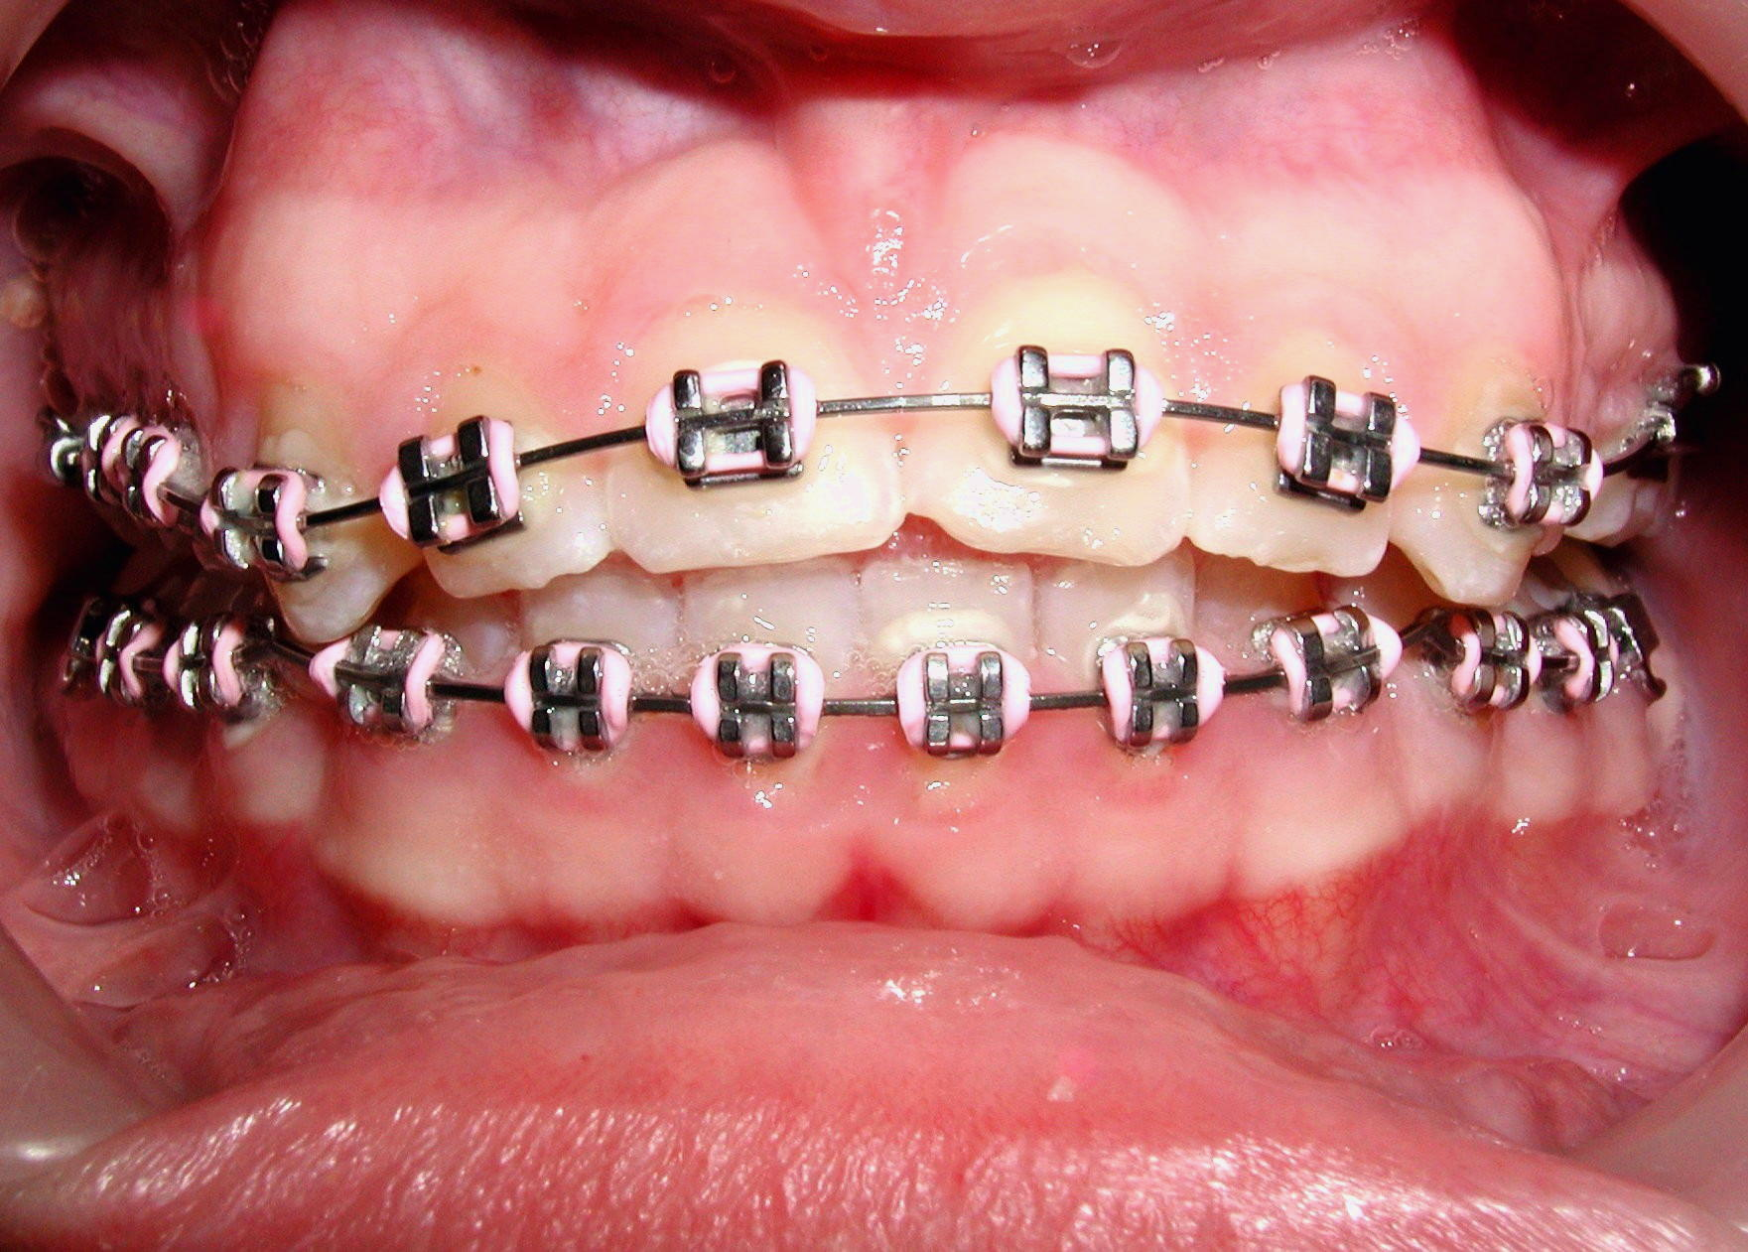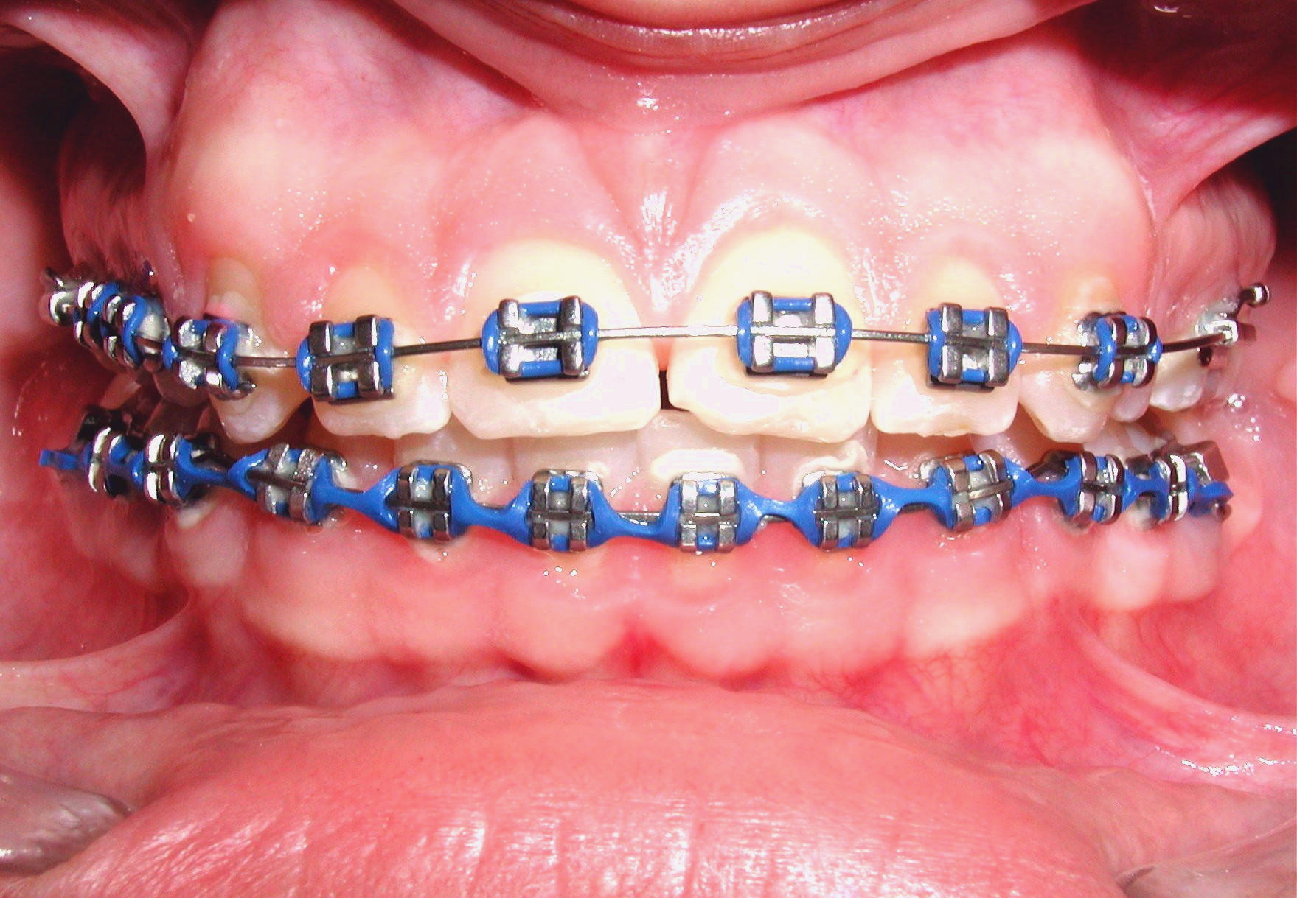
D
E
F
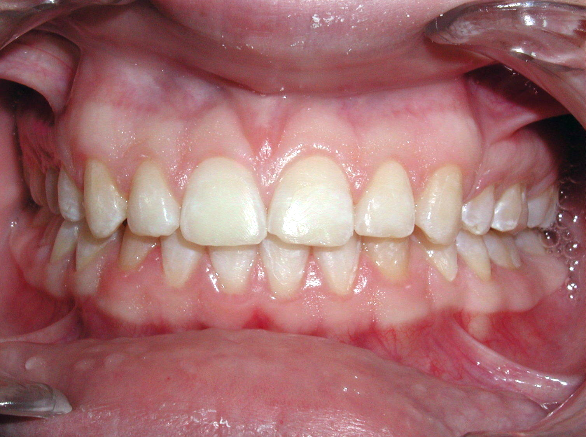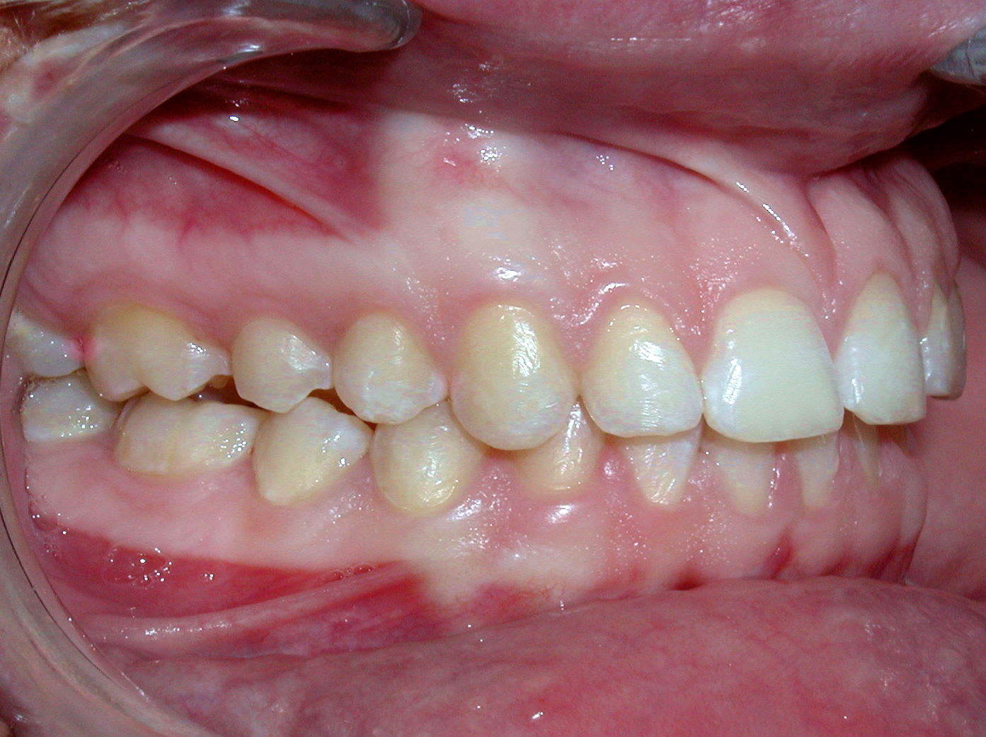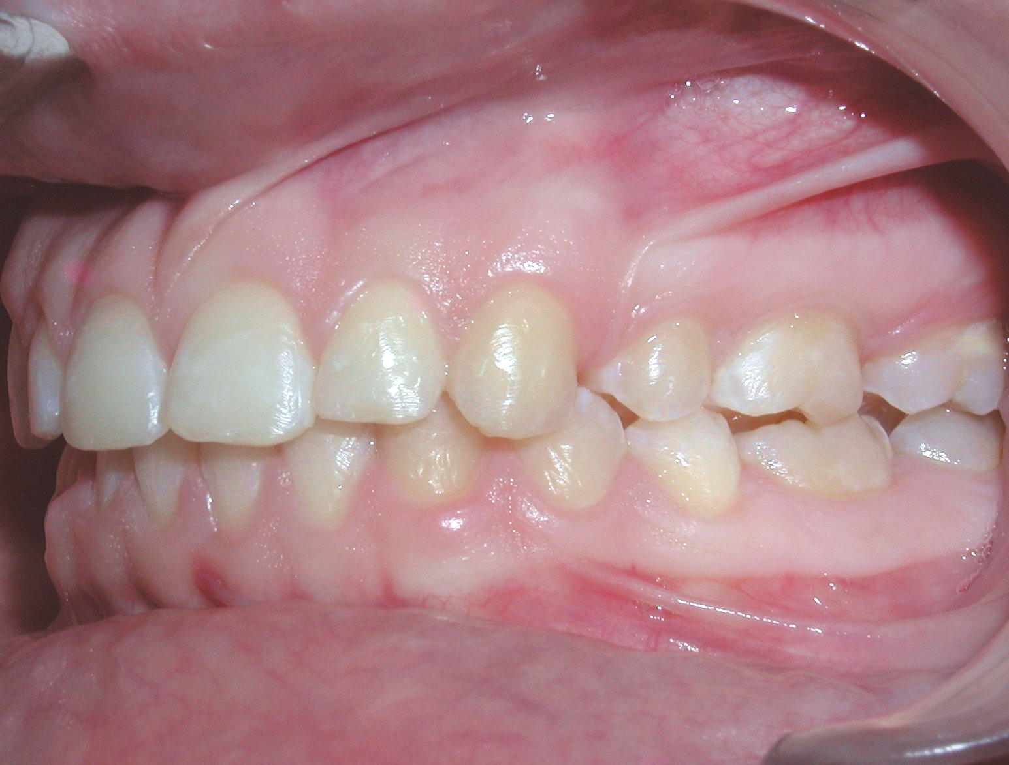
G
H
I
CASE 1. A. B. C, Pretreatment models of a Class I I Division 1 subdivision patient with 100% overbite. D. Intraoral photograph showing the V-bends intruded maxillary incisors enough to bond mandibular incisors. E. Shows effect of simultaneous V-bends on a 0.16” x 0.022 NiTi mandibular archwire that over corrected the overbite. F. Last stage of treatment where normal over bite /overjet relation are restored. G.H.I. Post treatment photograph during retention period with minimal relapse.
B
C
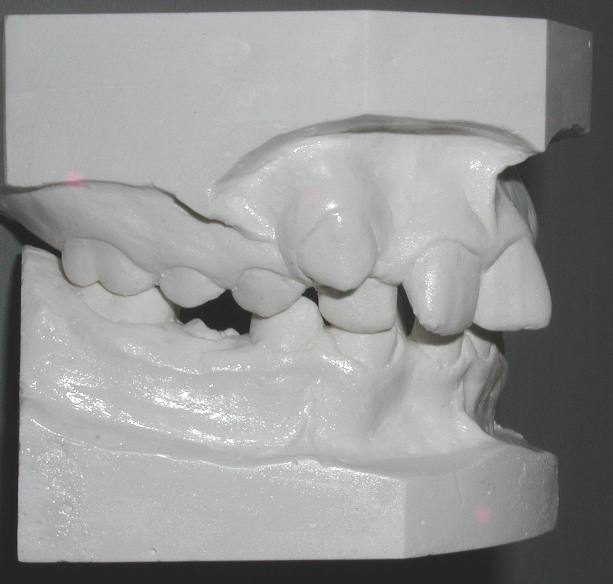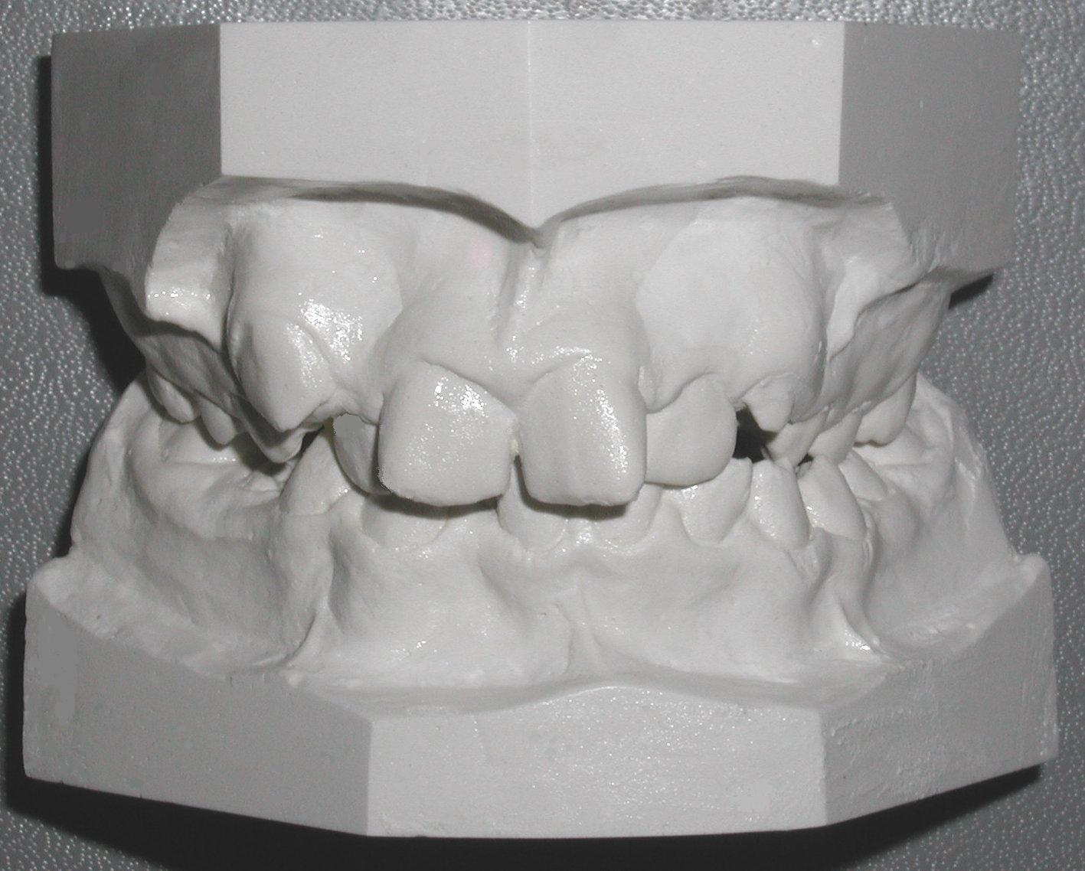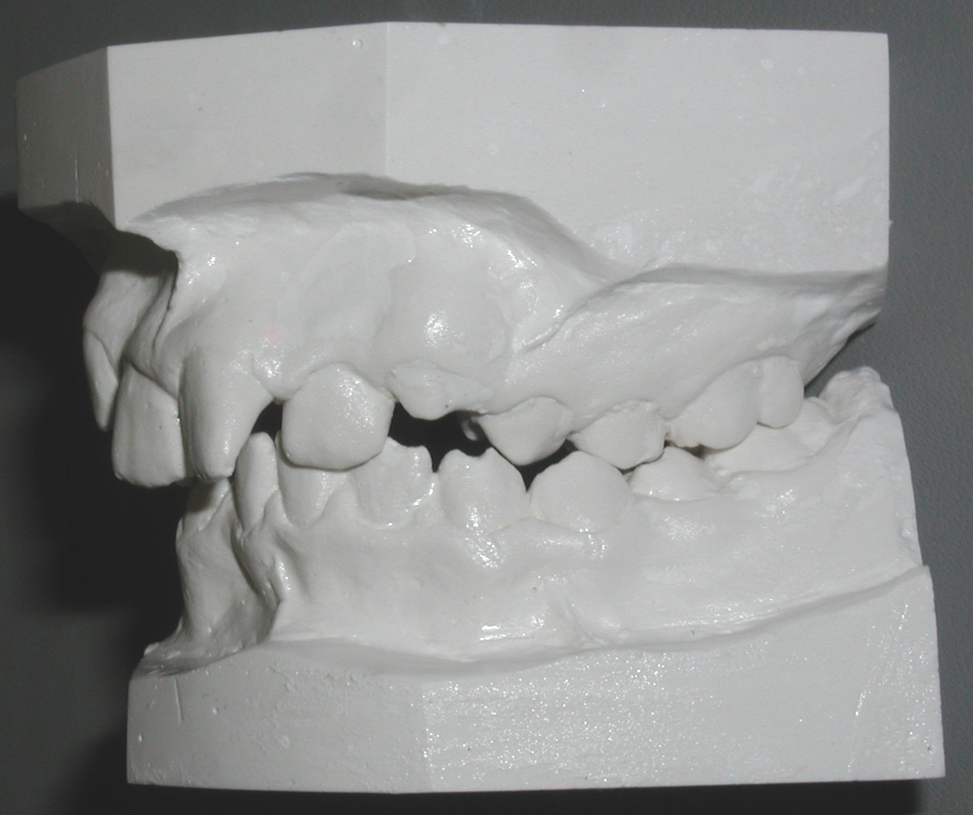
E
A
D
F
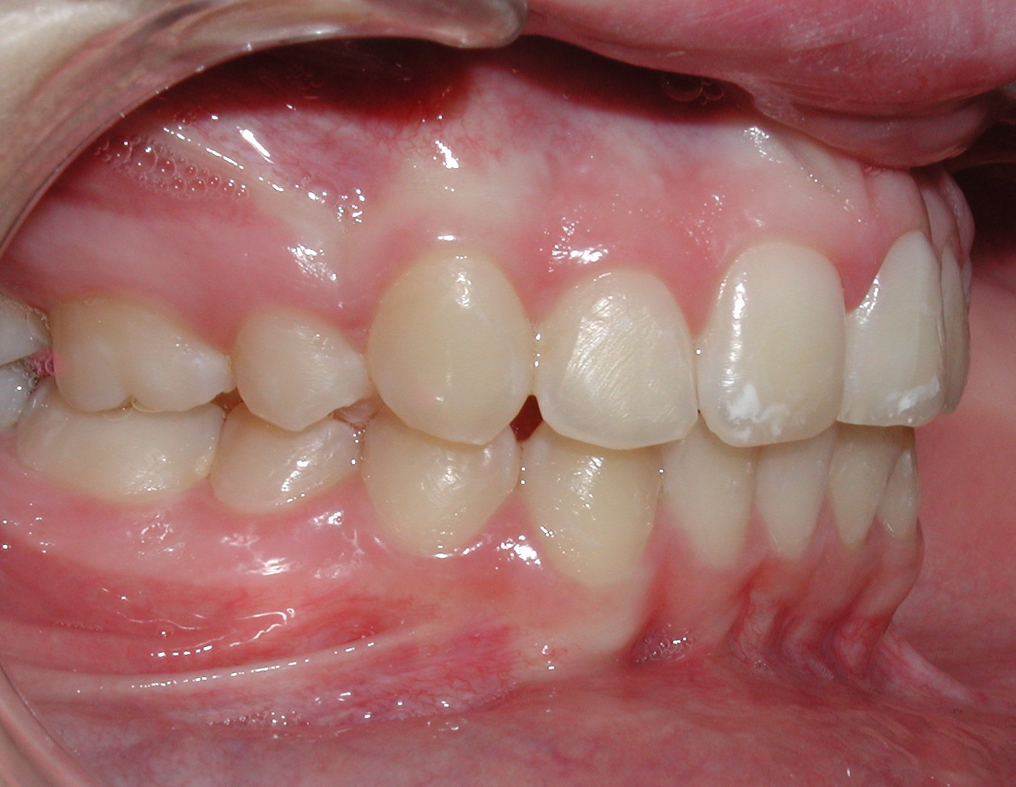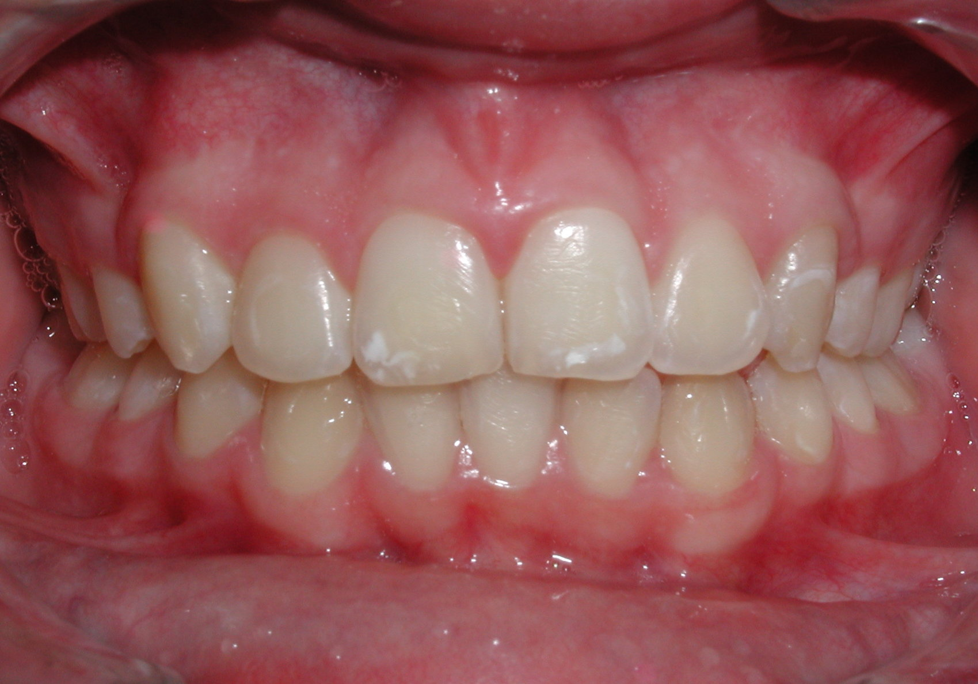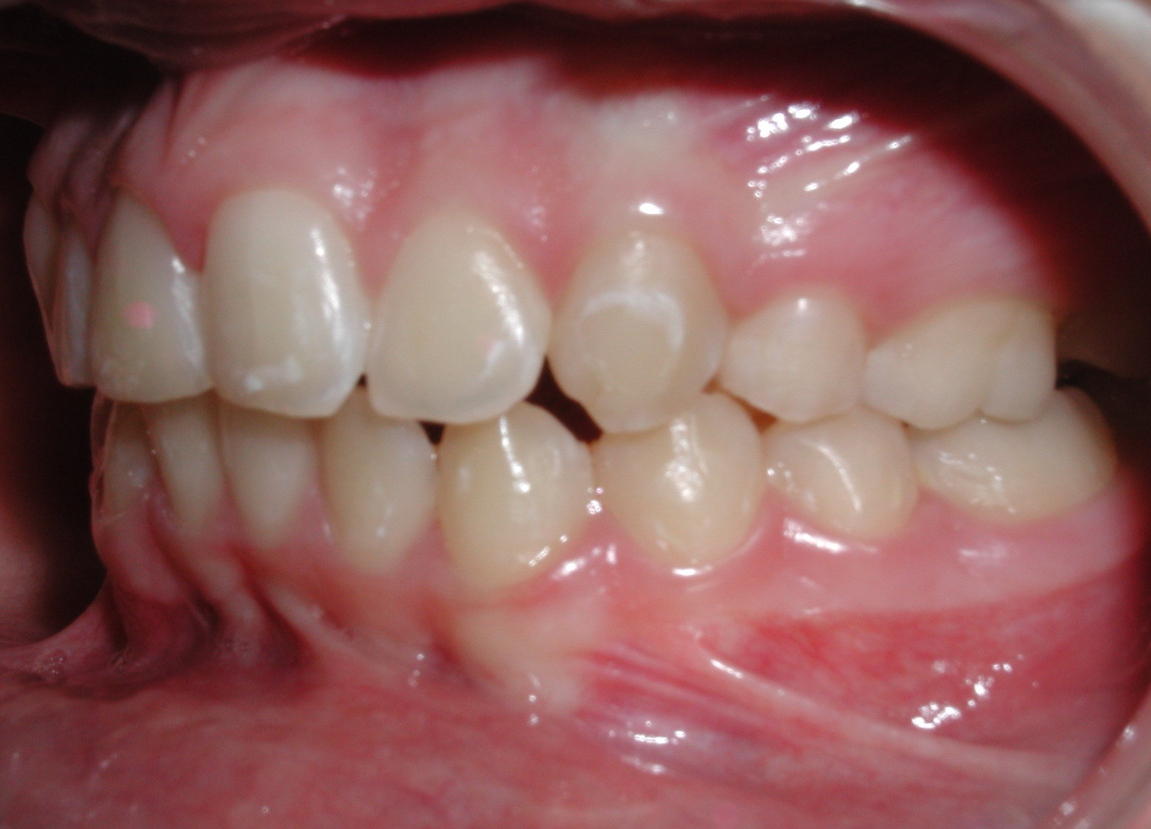
CASE 2.A.B.C. show pretreatment models of a Class II division 2 subdivision patient with severe overbite. D.E.F. shows post-treatment frontal intraoral photographs of the same patient treated by the V-bends technique for bite
opening. Normal overbite /overjet relations were restored nicely, but the tooth size discrepancy did not allow achieving normal canine relations.
B
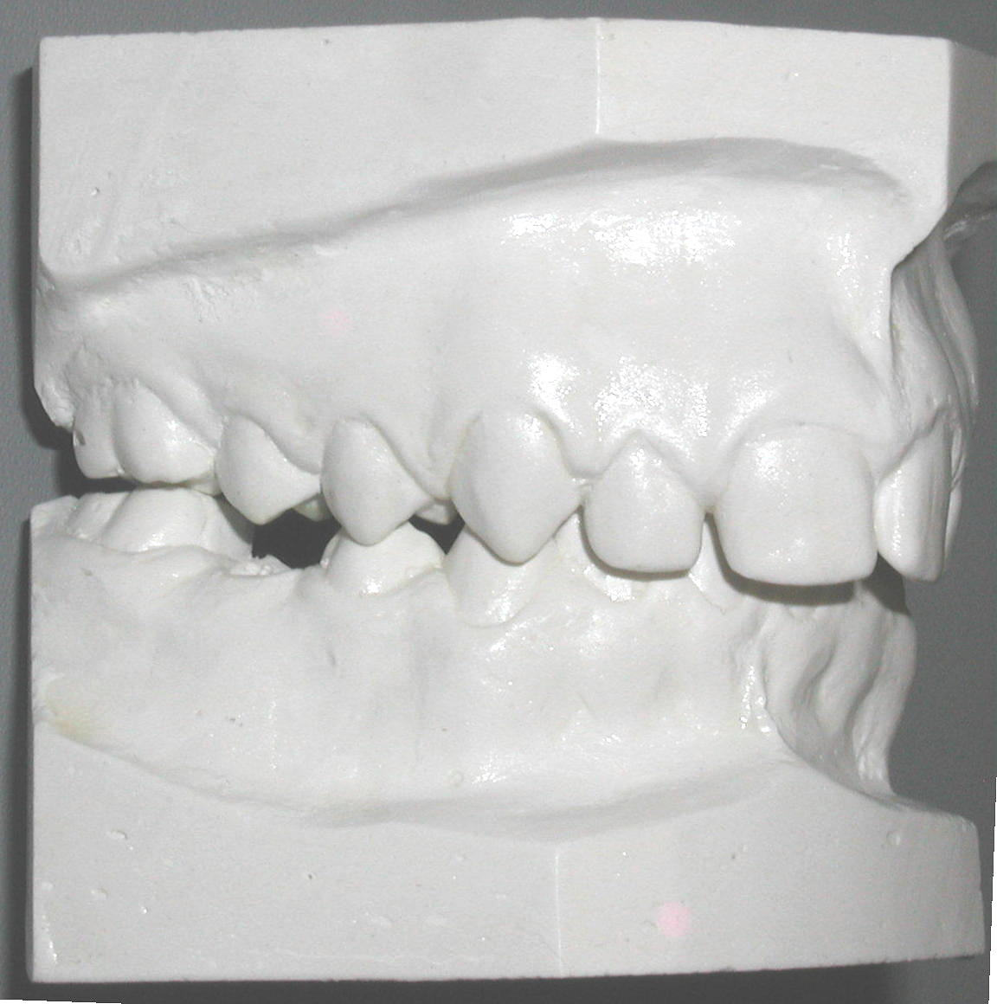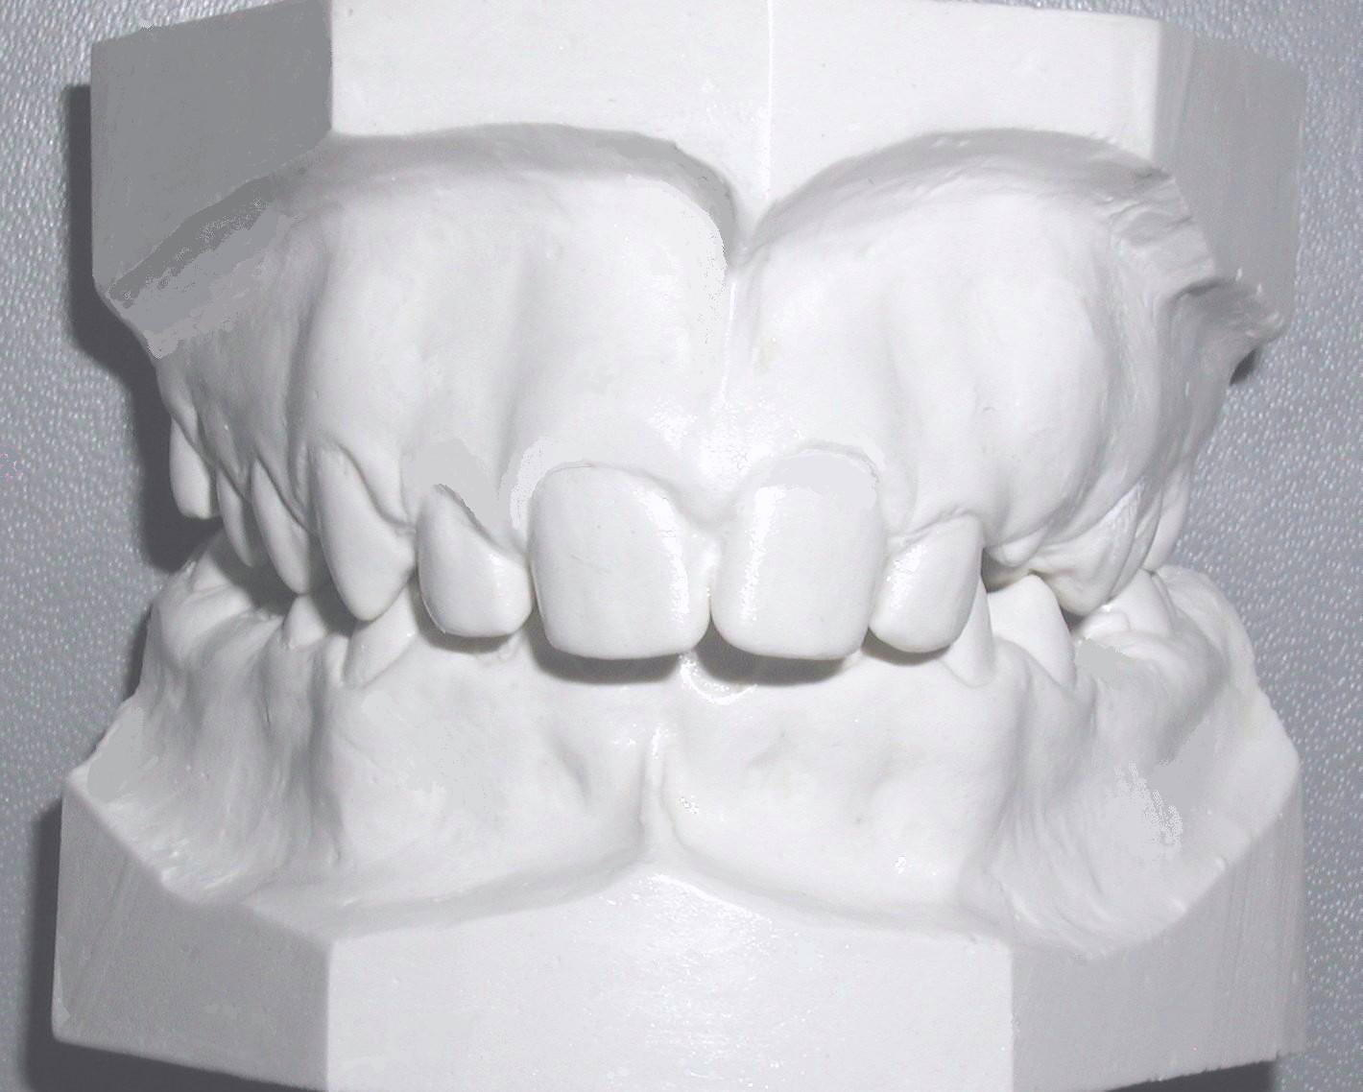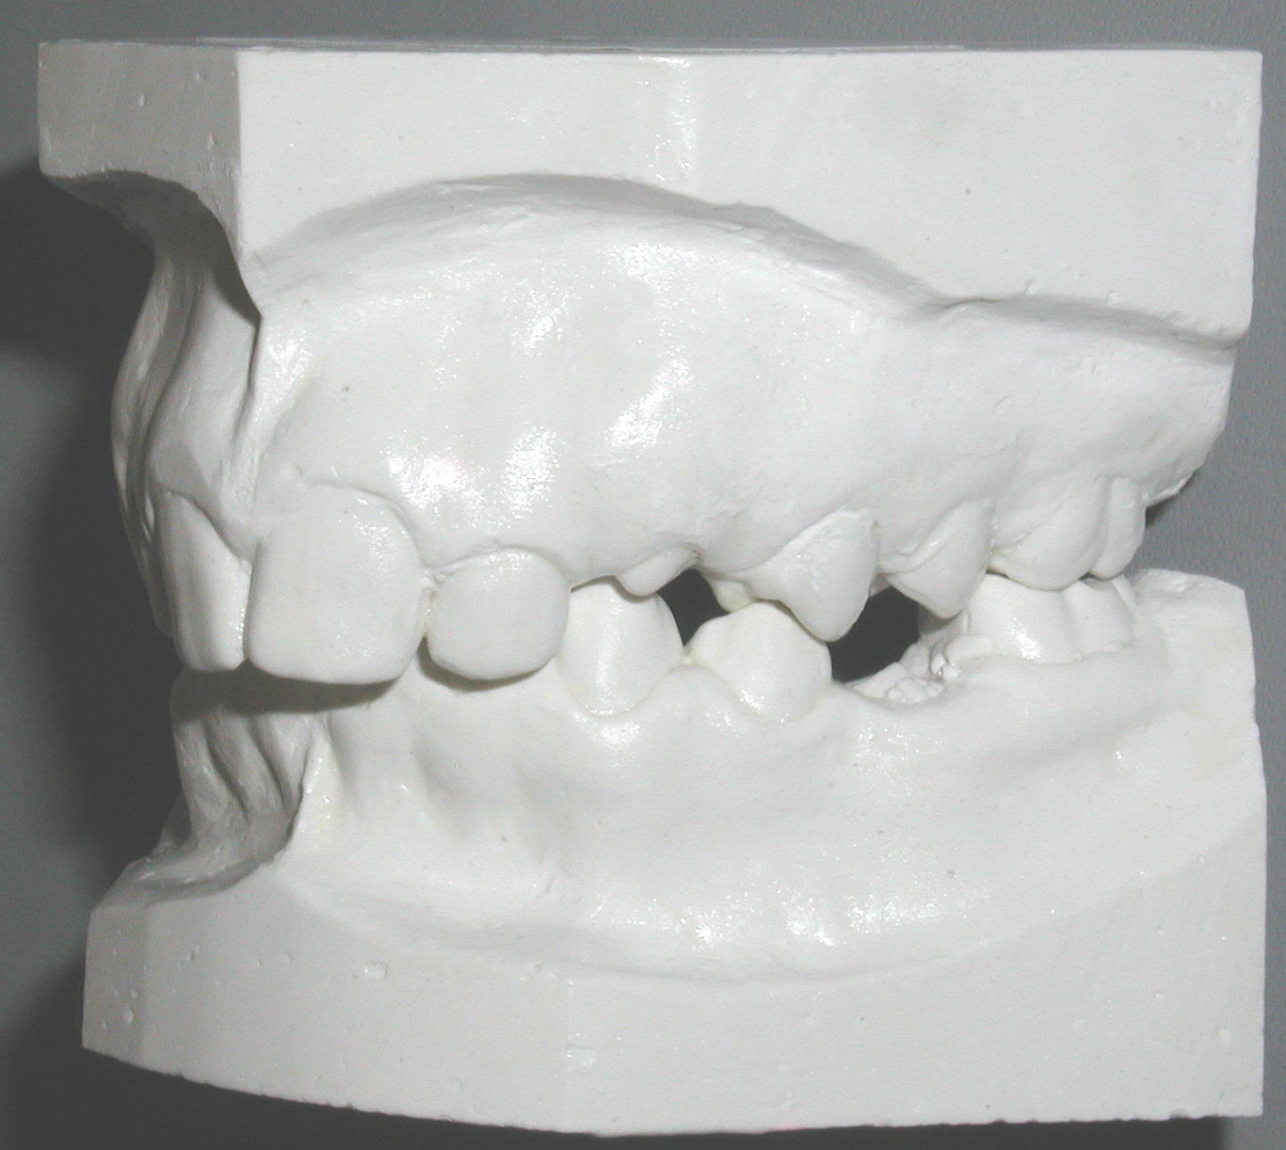
B
C
D
E
A
F
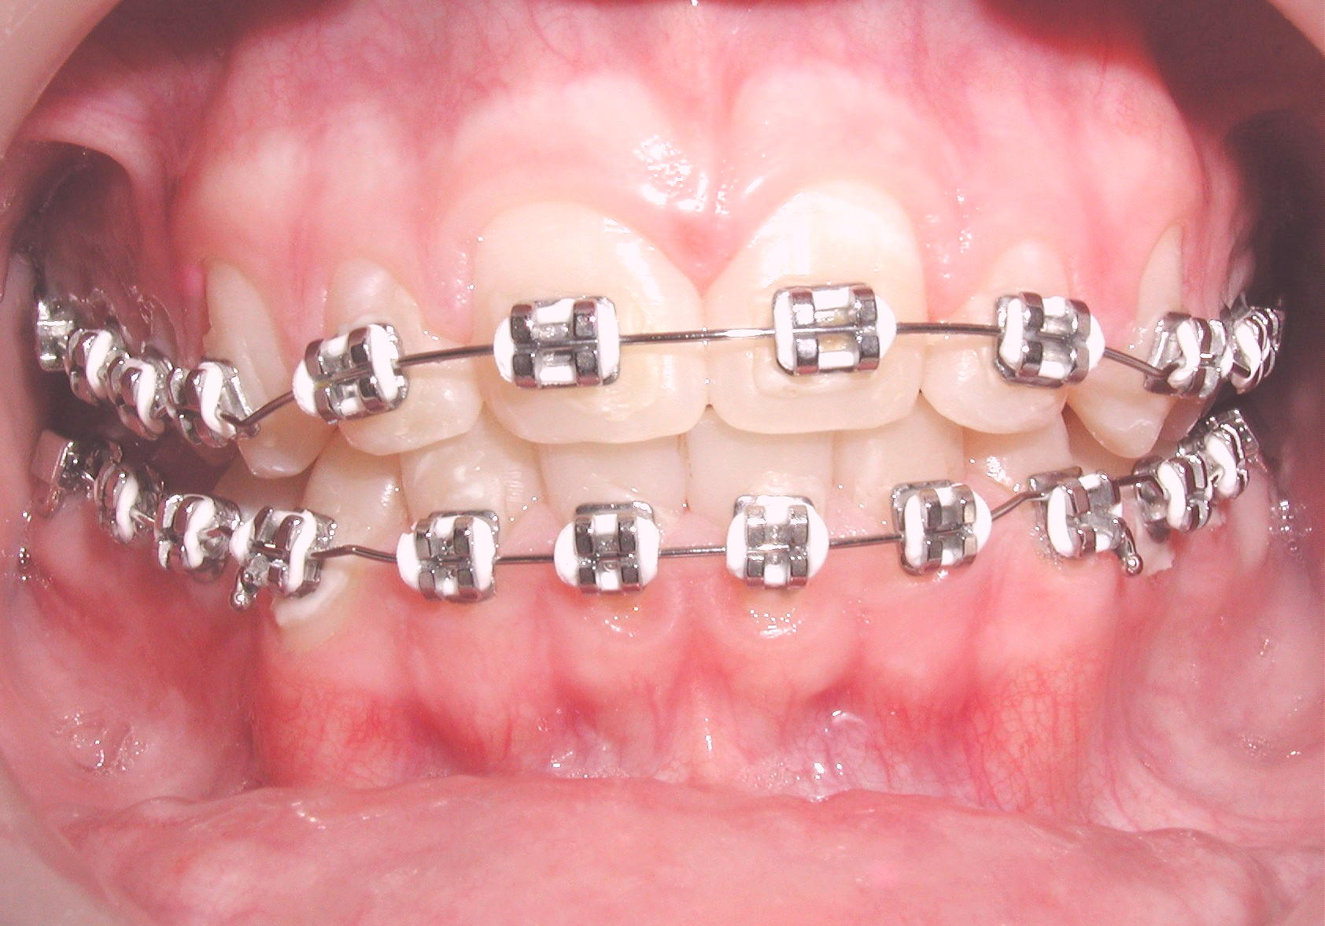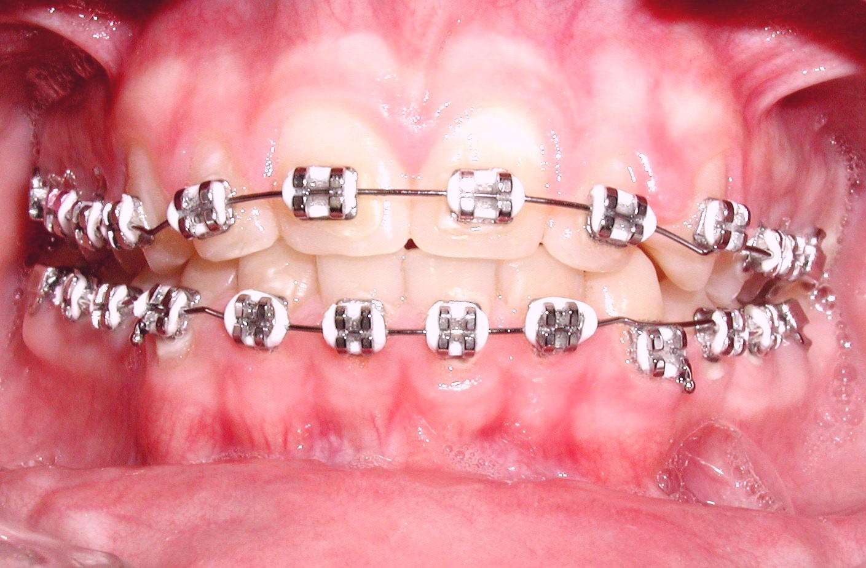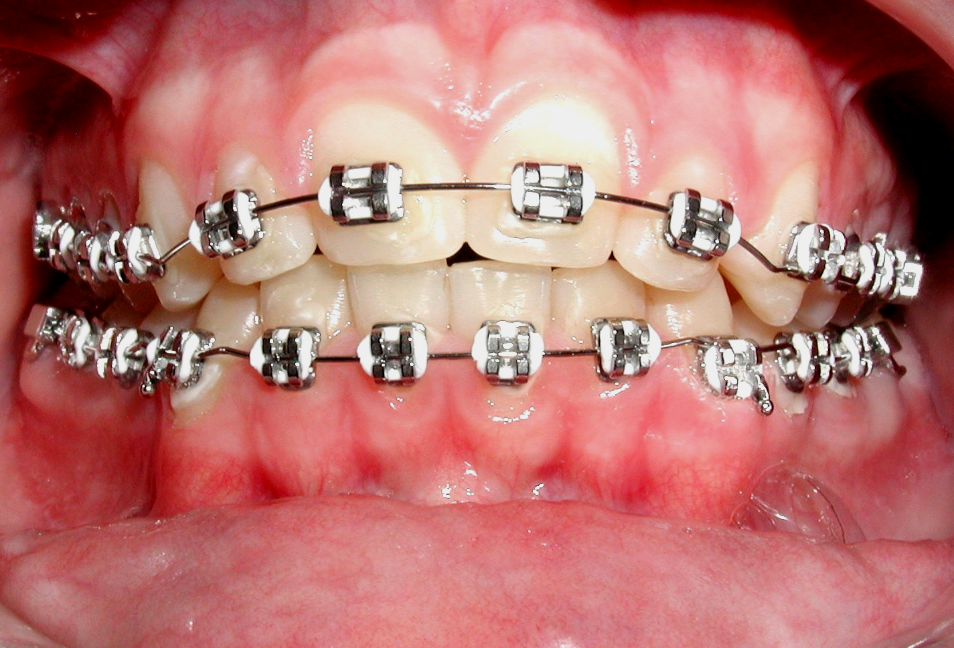
G
H
I
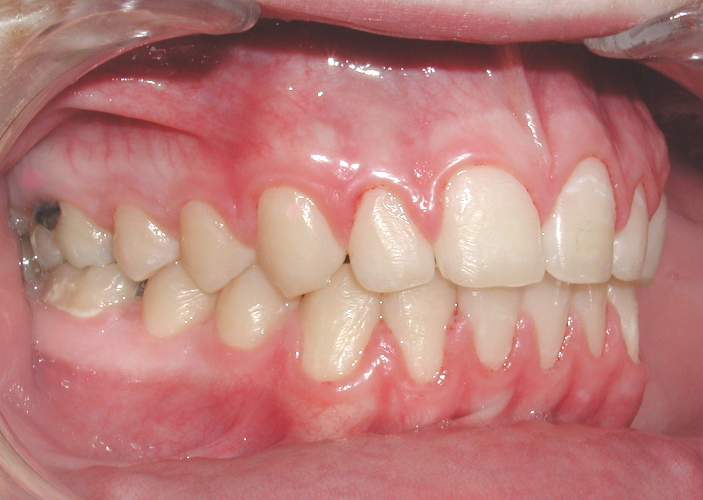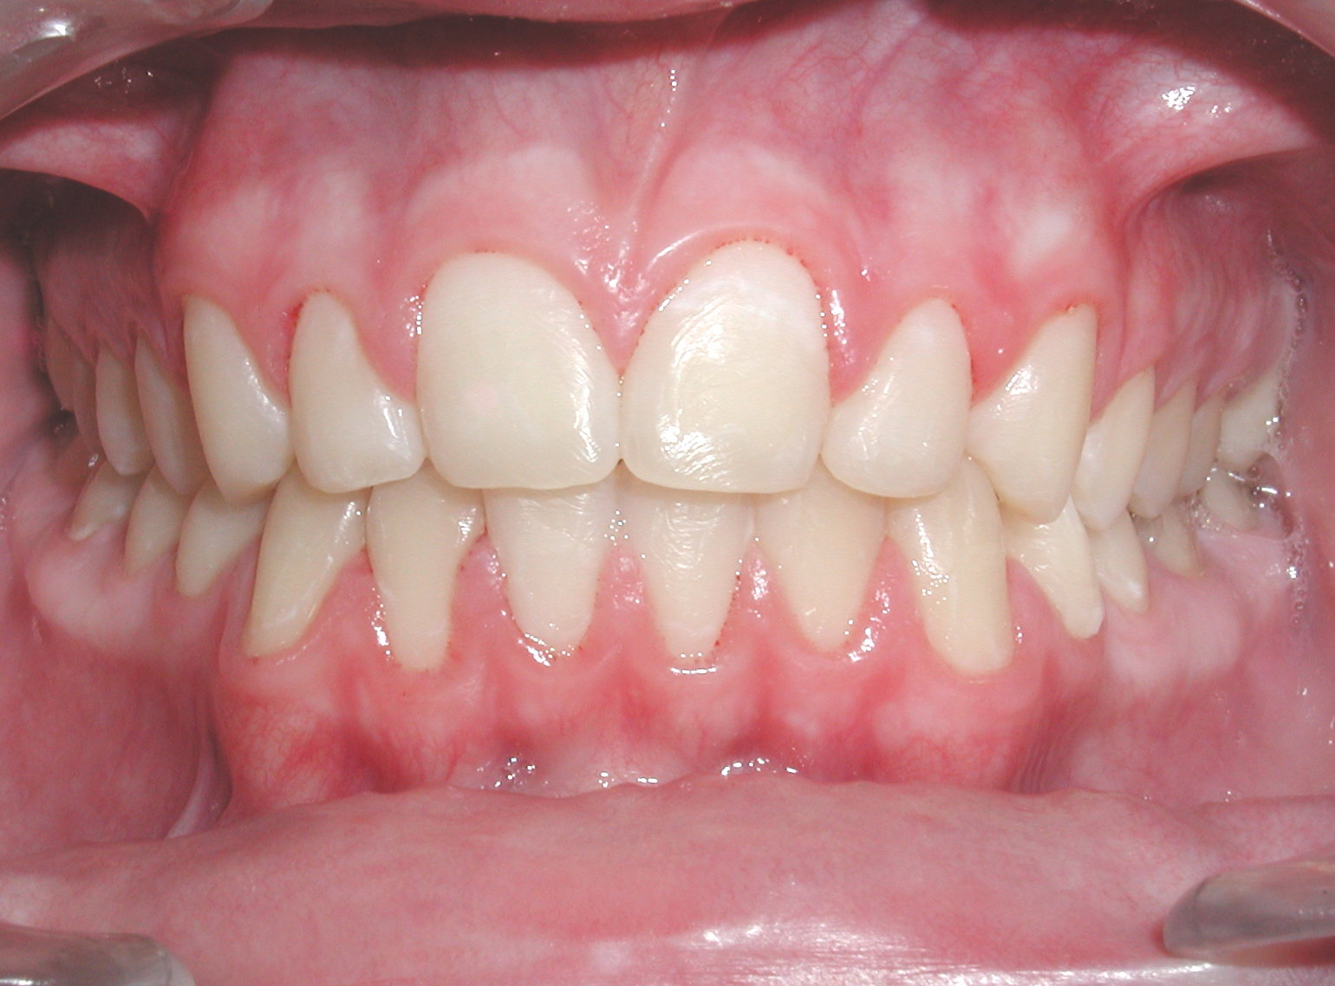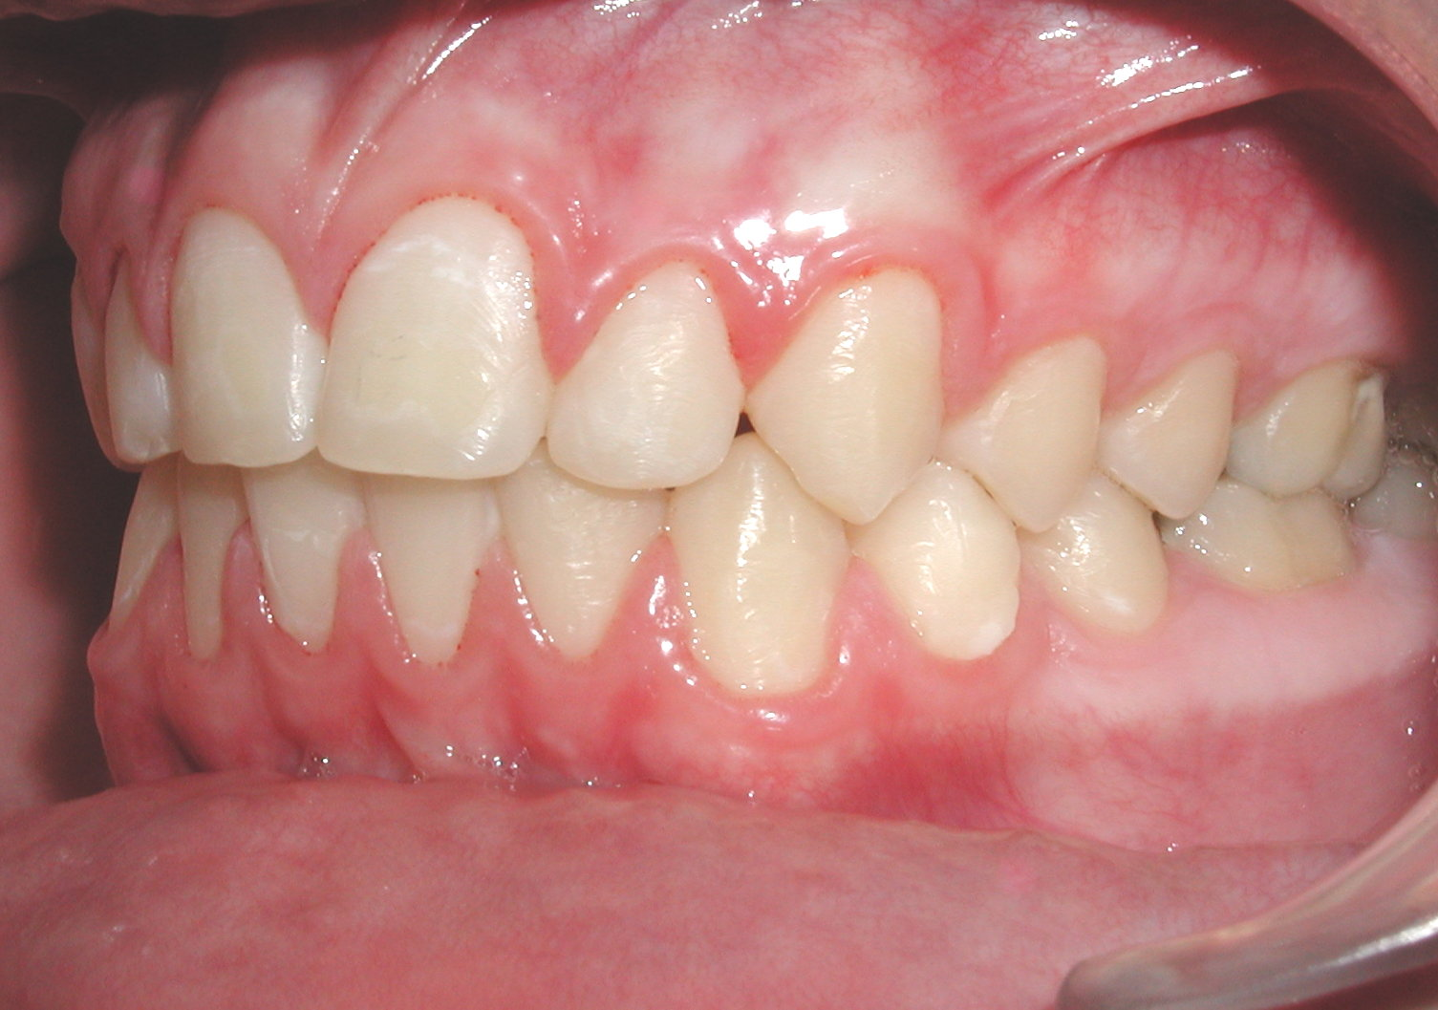
CASE 3 A.B.C. Pretreatment models of a severe overbite in a Class I patient, with. D.E.F. Same patient during treatment stages with V-bends technique after bite opening showing V bends on maxillary and mandibular NiTi rectangular archwires. G.H.I. Post- treatment intraoral photographs. Note the restoration of normal over bite using the V-bend technique.
A
B
C
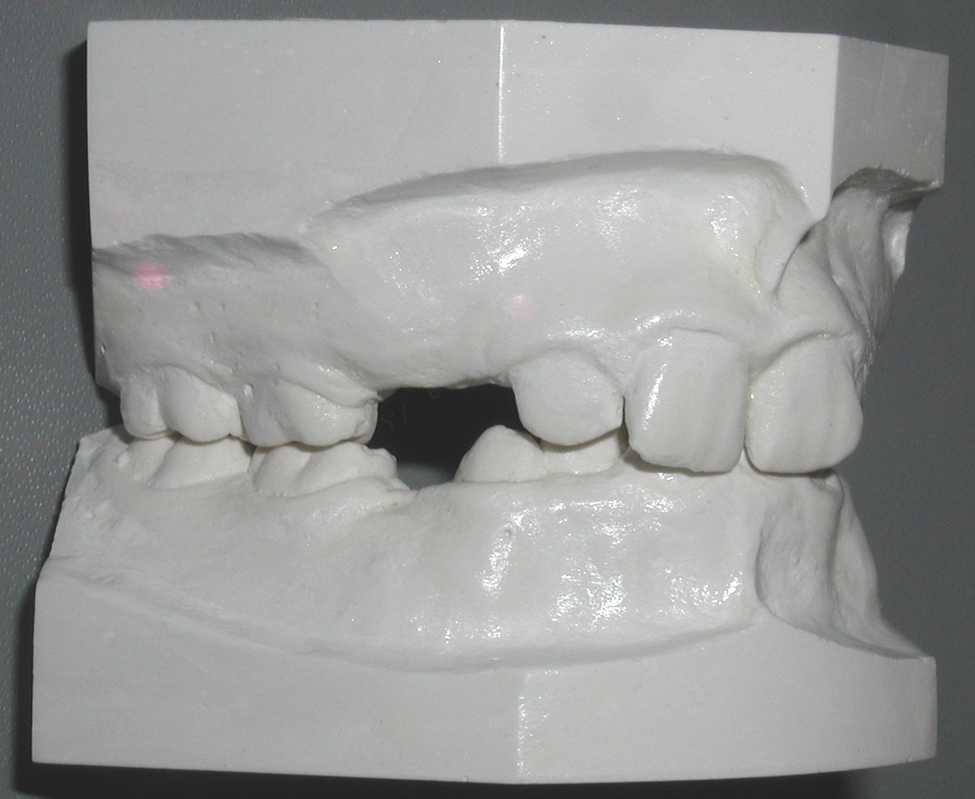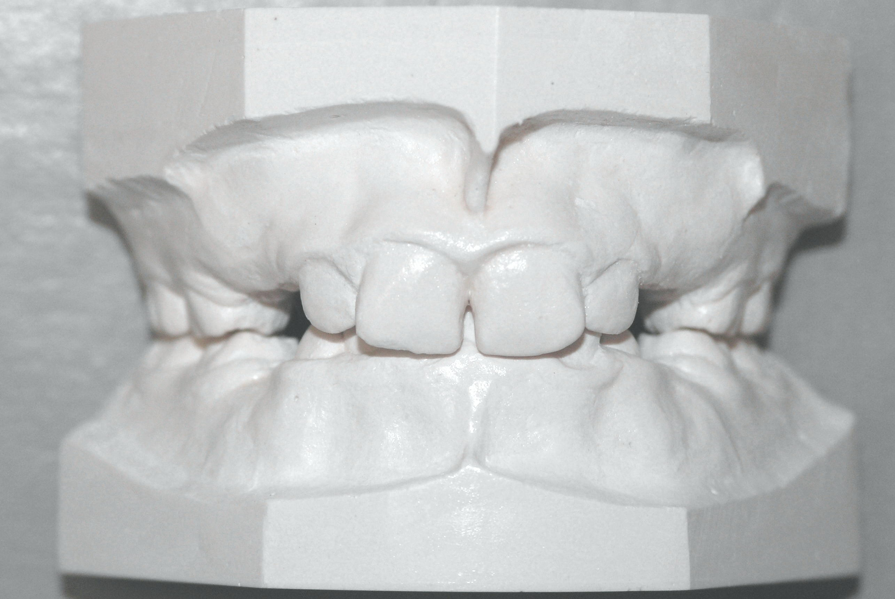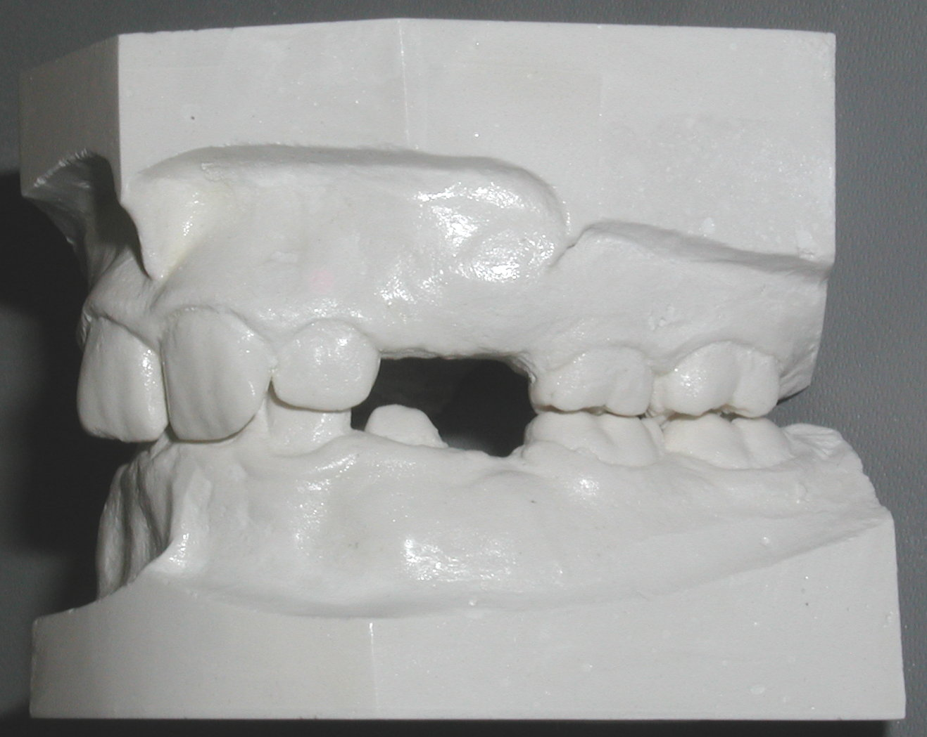
D
E
F
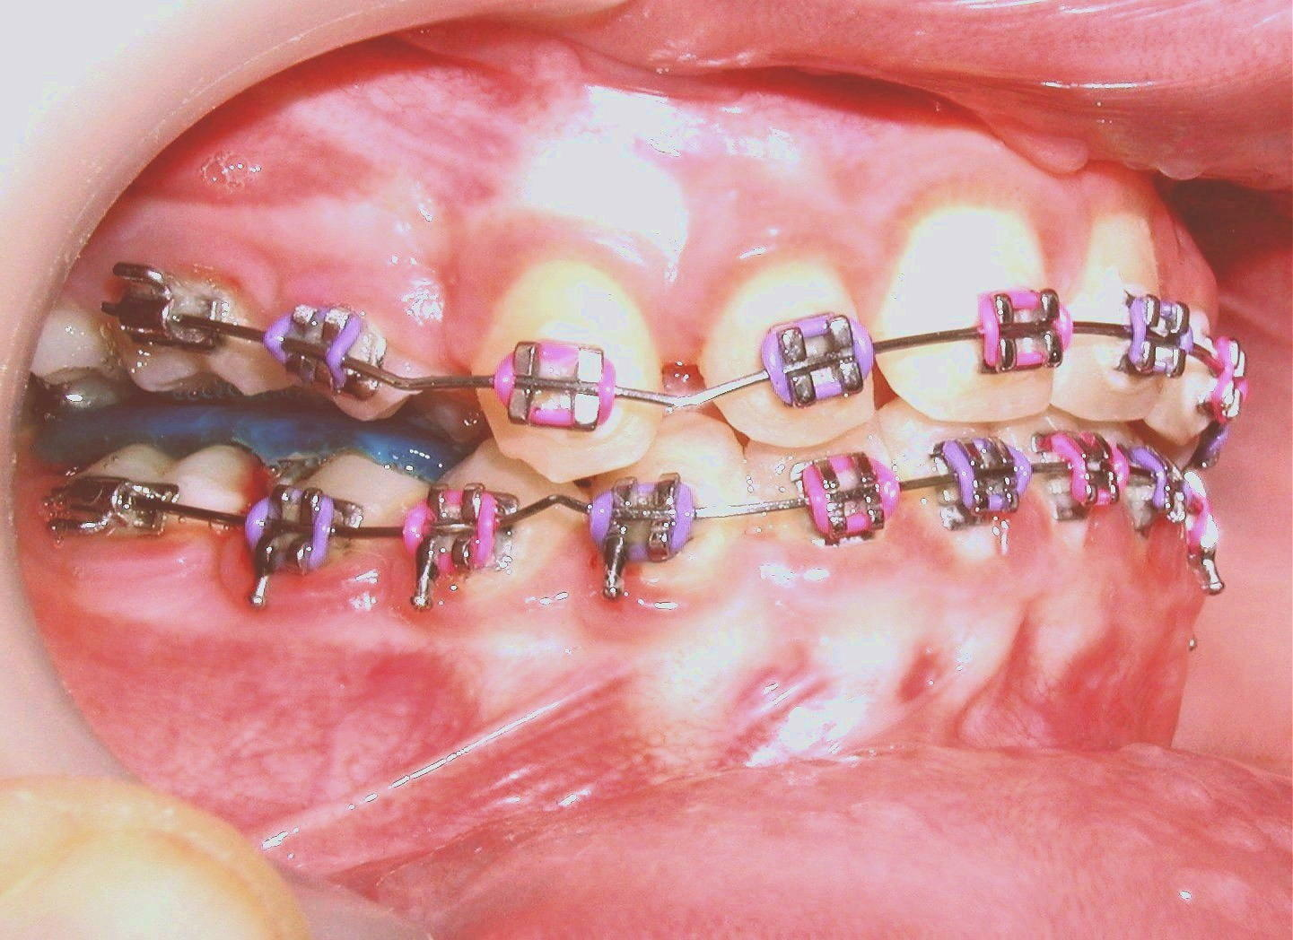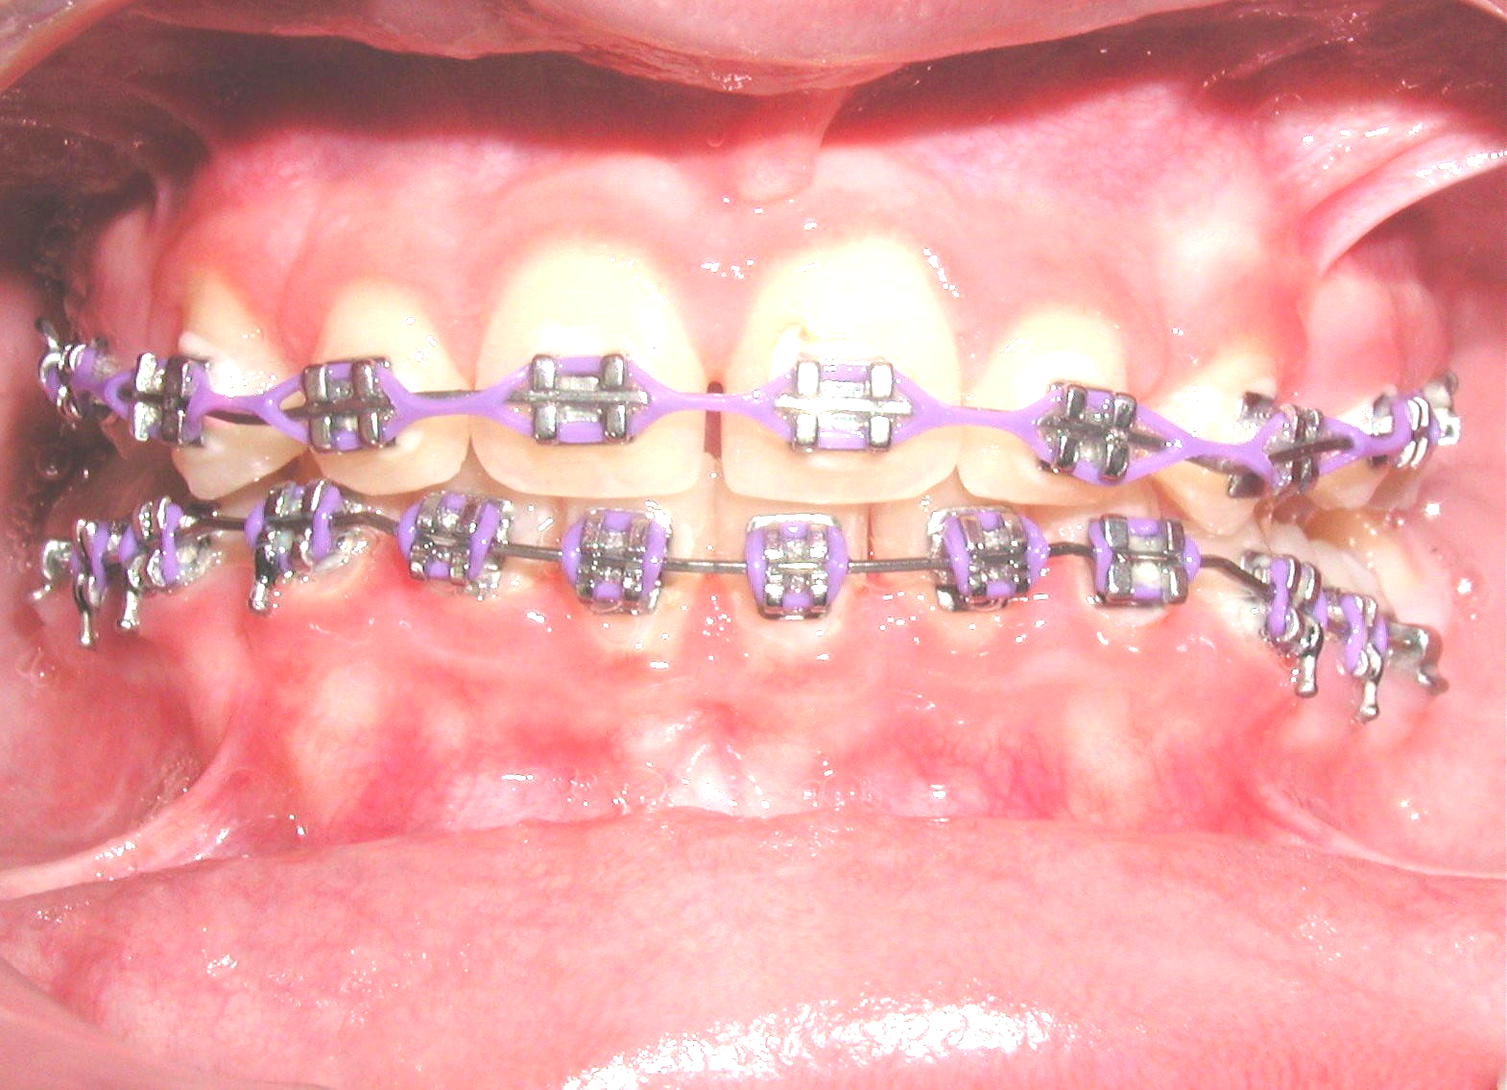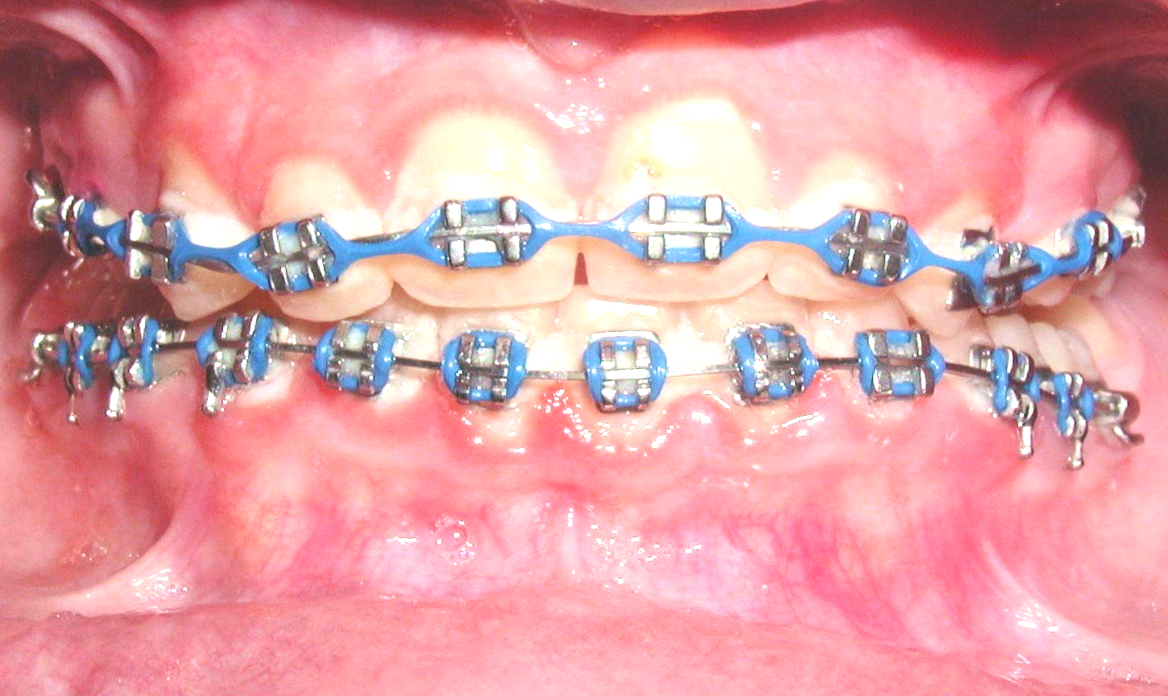
G
H
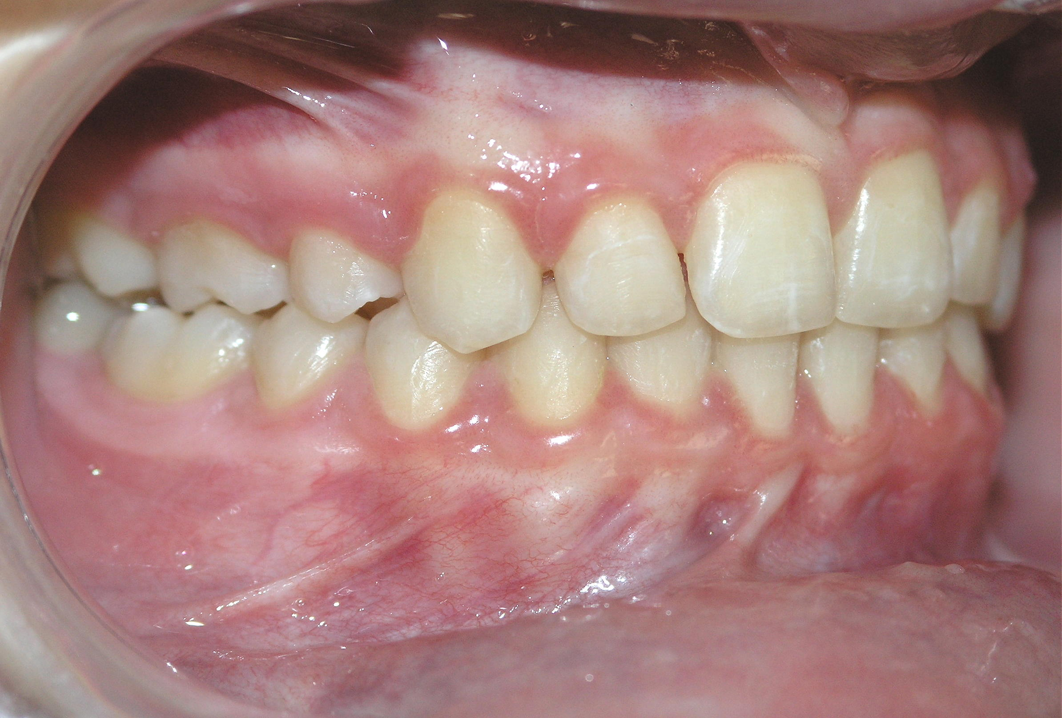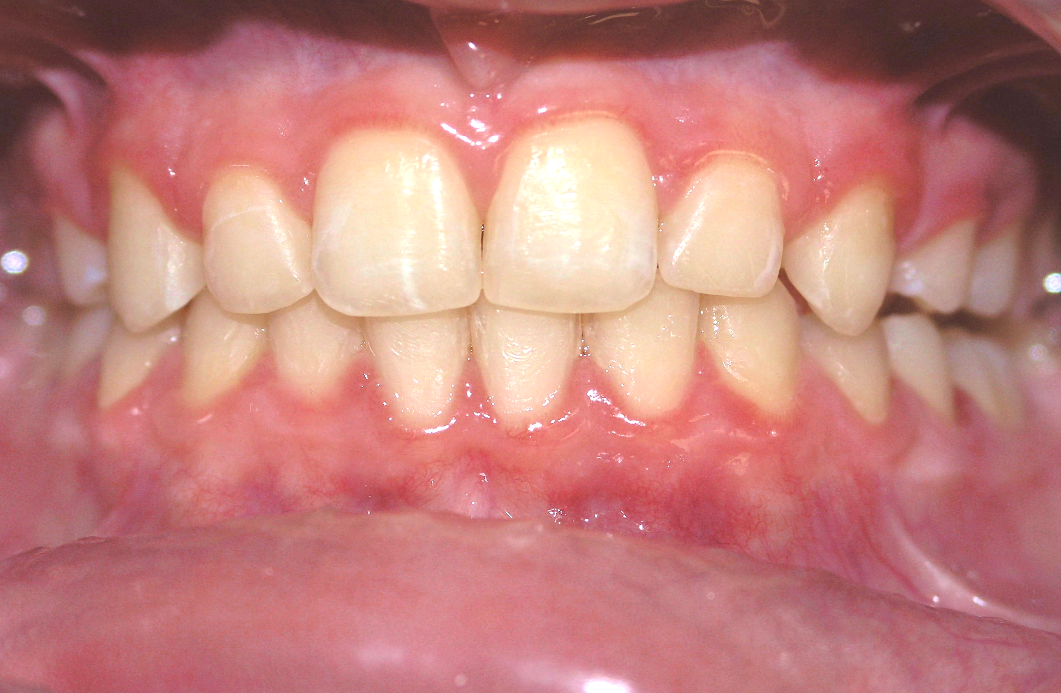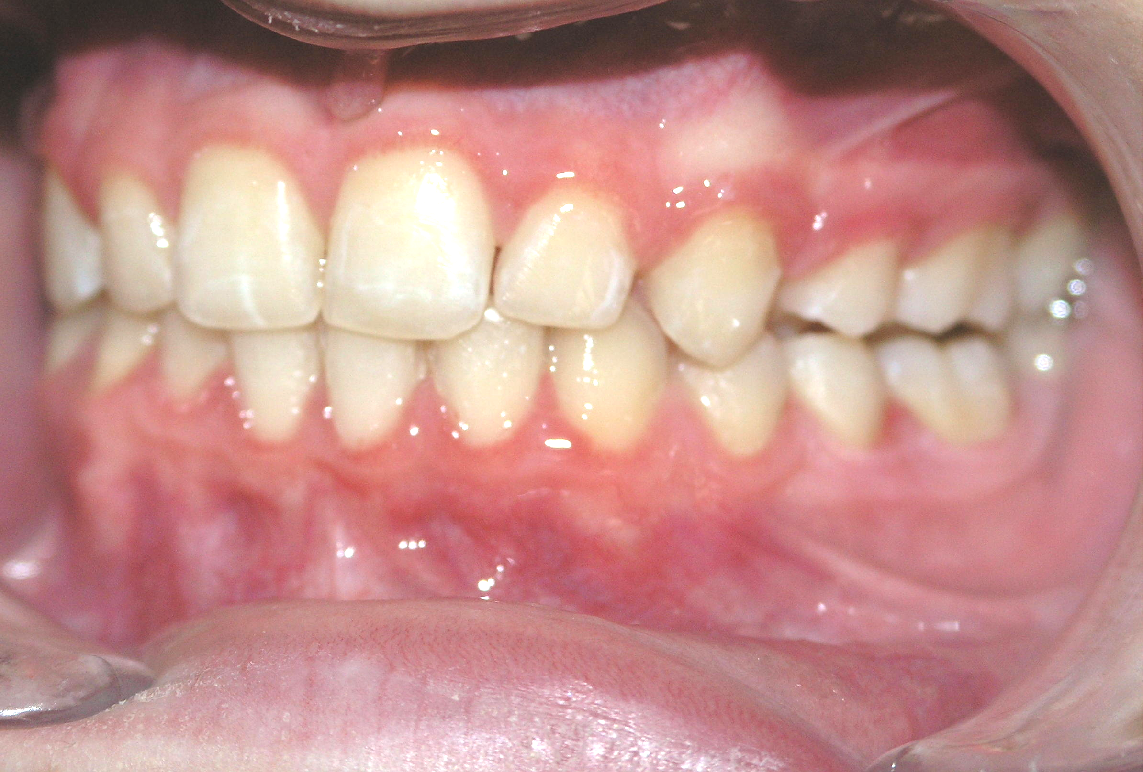
I
Case 4.A.B.C, Pretreatment models of a Class II Division 2 malocclusion and over 100% severe overbite. D. Lateral intraoral photograph shows the V-bends on both arch wires with blue bite plate in place to raise the bite and bond mandibular teeth. E.F. intraoral frontal views showing two stages of bite opening treatment. Note the over treatment achieved. G.H.I. post-treatment intraoral photograph shows restoration of over bite/overjet relations to normal using this new technique.

A
B
C
C
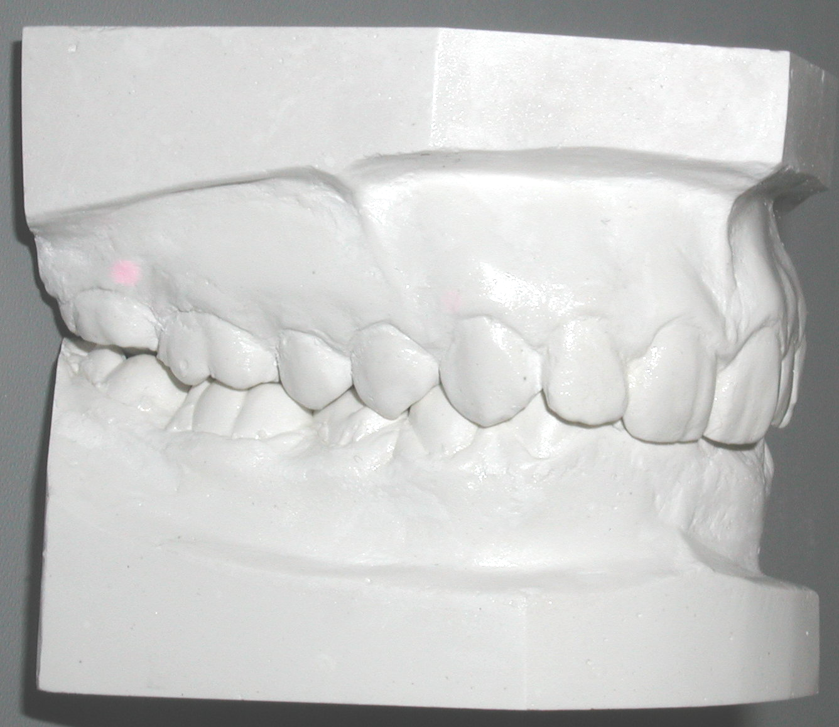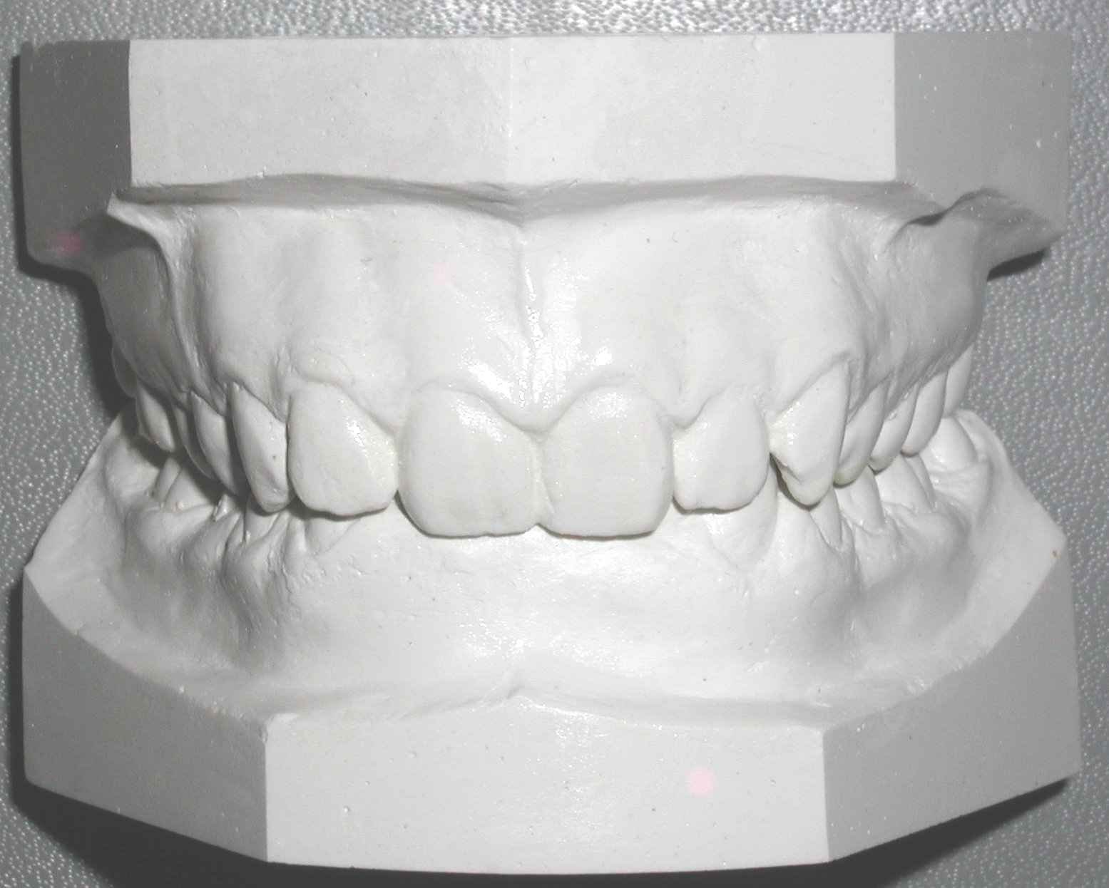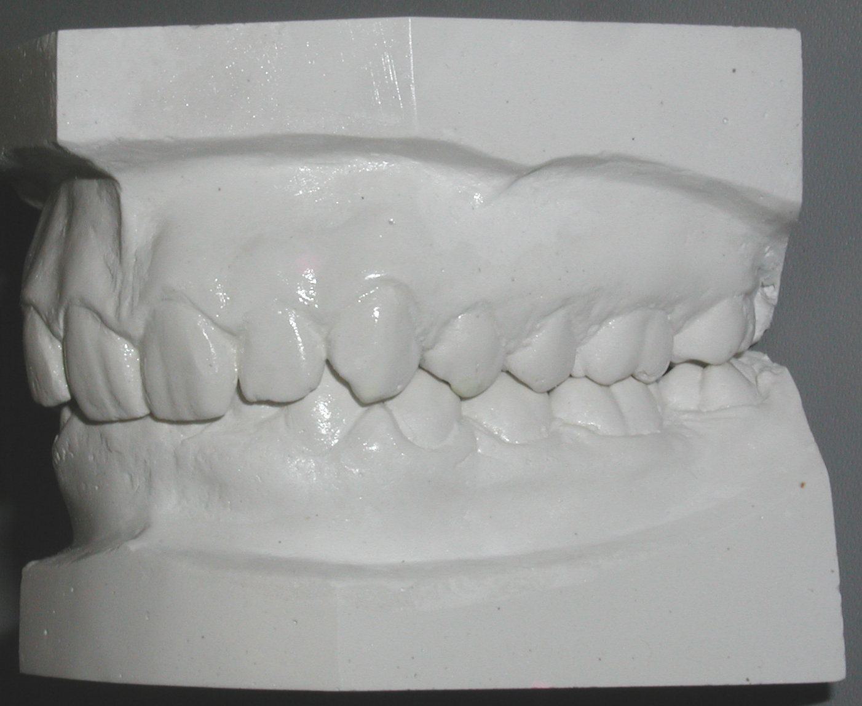
E
F
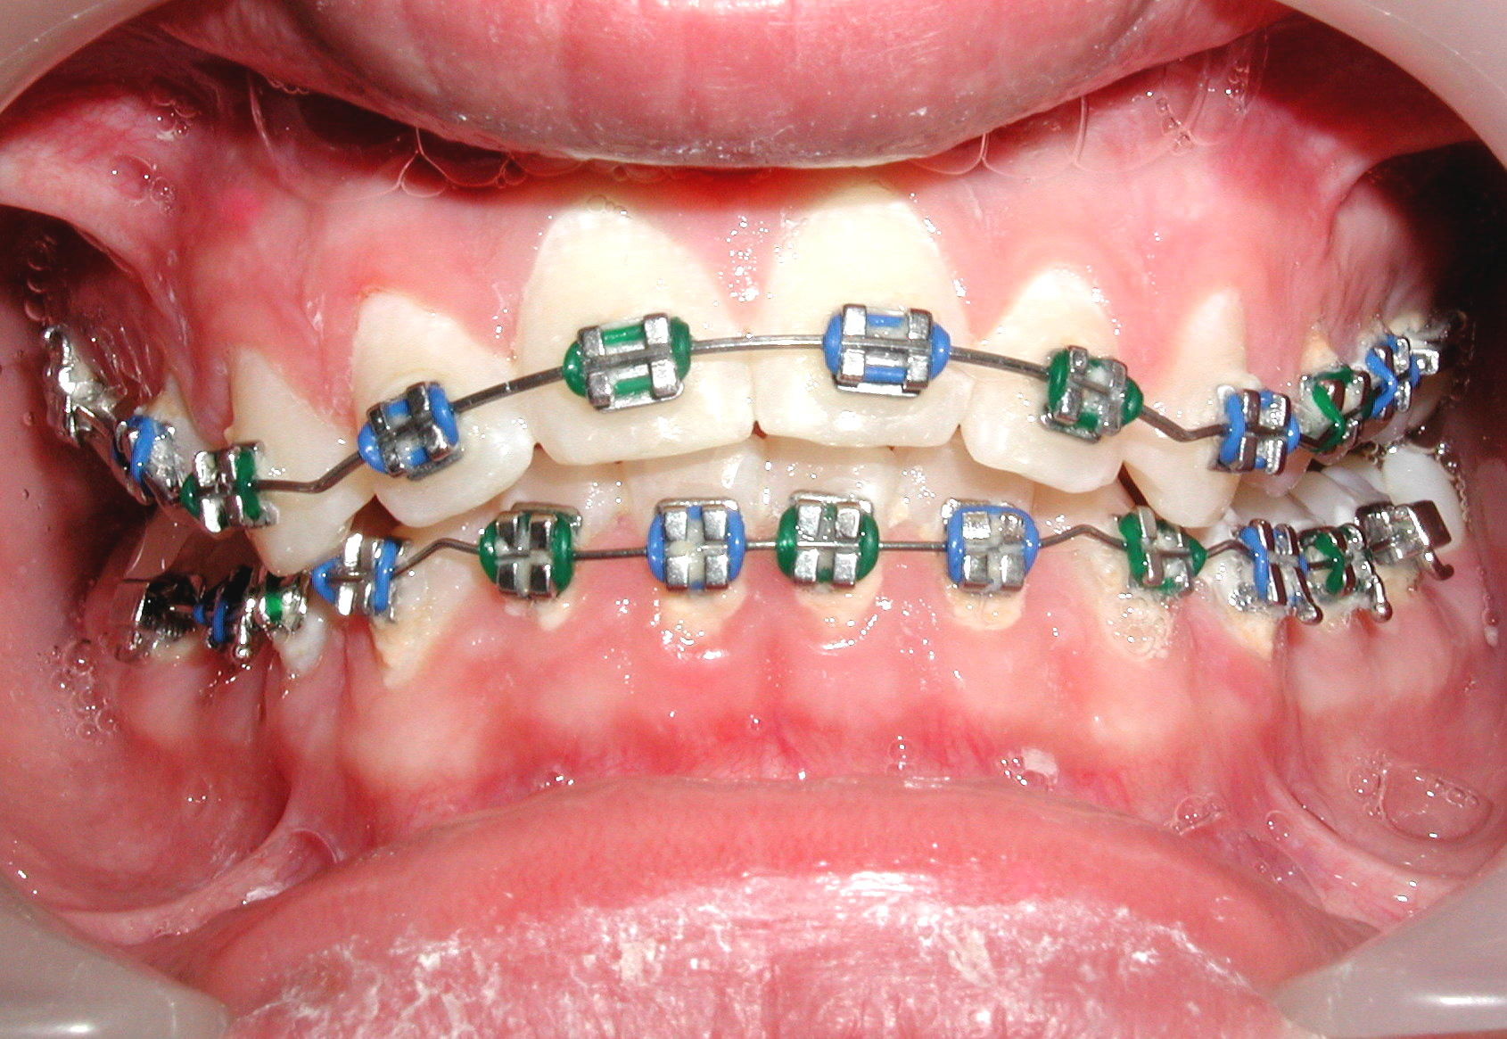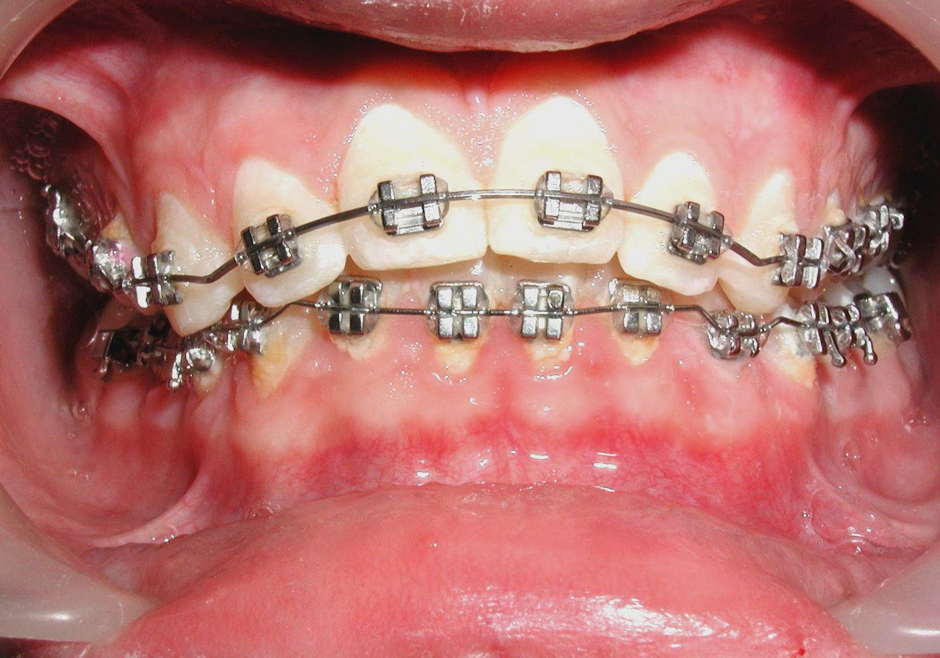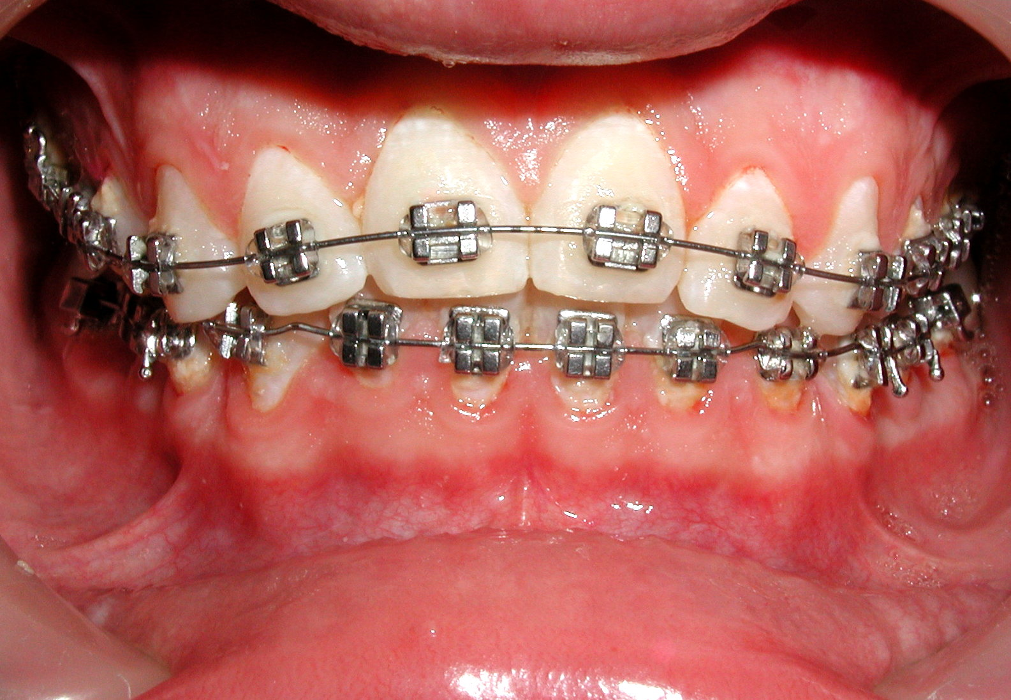
D
G
H
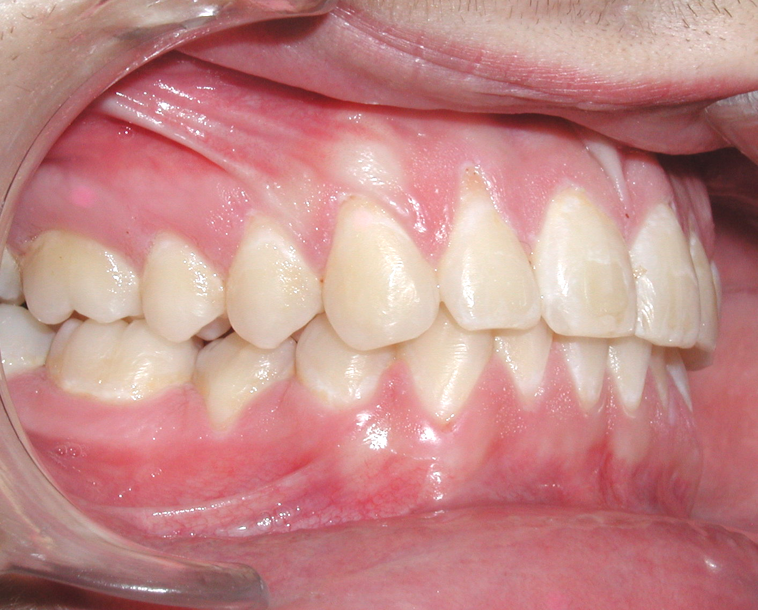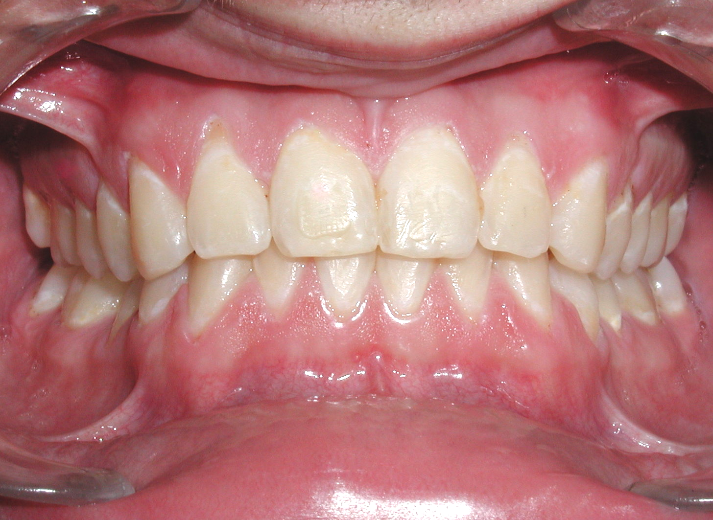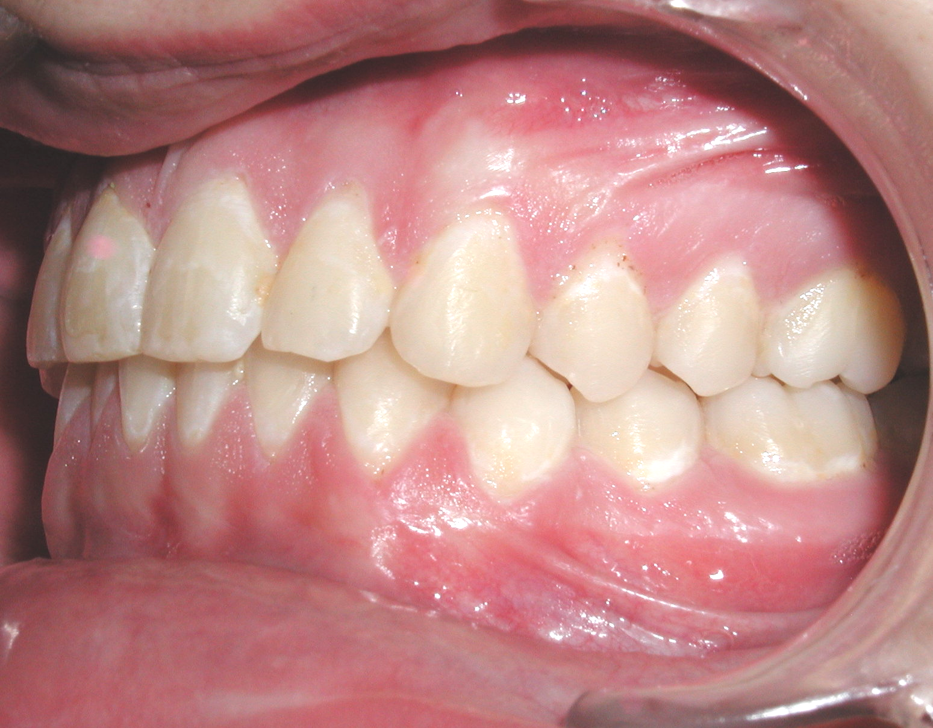
I

Case 5.A, Frontal view of pretreatment models of a patient with severe over bite. B. Frontal view of the same patient showing that the V-bends not only corrected the overbite, but over treated it when the intrusive archwire remained in place long enough. C. Post treatment result with bite opened to normal limit. D. Post treatment panoramic radiograph showing no significant resorption.

Discussion
Orthodontic researchers and authors have not yet offered orthodontists an easy and clinically applicable method for correcting deep overbites using super elastic wires. This professional deficit has occurred primarily due to lack of instrumentation to activate the highly flexible, brittle NiTi archwires.
The new Bendistal Pliers provide the proper armamentarium needed to control such wires and offer the following advantages:
- The tiny jaw tips of the pliers easily fit between brackets and allow making the bends without wire or bracket breakage.
- The light and consistent forces produced by these intraoral bends provided efficiency in tooth movement and convenience to clinicians and patients.
- The long range of activation of super elastic wires resulting from single bends increases magnitude of intrusion and minimizes the number of adjustments.
- The mass tooth-moving effect of these V-bends creates the optimal intrusive forces system created by traditional appliances and in a segmental format.
Patients presented in this article illustrate the simplicity, efficiency, convenience and time conservation V-bends can offer in the solution of such a difficult orthodontic problem. Clinicians can customize placement of intrusive or extrusive V-bends without the need for using costly prefabricated traditional bite opening appliance designs, lab work or rely on patient cooperation.

Conclusion
This presentation describes a simple, effective and clinically applicable alternative bite opening technique using V-bends on super elastic wires that are created by new orthodontic pliers. Cases treated in this article showed that this instant treatment modality is clinically accessible to orthodontists and can efficiently correct a wide variety of excessive overbites in class I and II malocclusions. This new technique can be performed during the regular orthodontic adjustment visits, without the need for costly and time-consuming prefabricated appliances or laboratory works. Future research is needed to quantify the amount of dental and skeletal changes elicited by this technique and compare its efficiency with other conventional bite opening modalities.

References

1. Khouri, S.A., A solution for distal end bending of super elastic wires. Am J. Orthodon Dentofacial Orthop, 1998. 114: p. 675-676.
2. Khouri, S.A., Using the bendistal pliers for the correction of common orthodontic problems. World J. Orthod, 2002. 3(2): p. 172-174.
3. Burstone, C.R., Deep overbite correction by intrusion. Am J. Orthodon Dentofacial Orthop, 1977. 72(1): p. 1-22.
4. Mahoney, D.R., Witzeg, J.A., A modification of the twin block technique for patients with a deep bite. Functional Orthodon, 1999. 10(April-June): p. 4-8.
5. Demisch, A., Ingervall, B, Thur, U., Mandibular displacement in Angle Class II division 2 malocclusions. Am J. Orthodon Dentofacial Orthop, 1992. 102(6): p. 509-518.
6. Delair, J., Sagittal splitting of the body of the mandible (Mehmet's technique) for correction of open bite and deep over bite. J. Maxillofac Surg, 1977. 5(2): p. 142-145.
7. Hinkle, F.G., Surgical treatment of adult Class II division 2 malocclusion. Am J. Orthodon Dentofacial Orthop, 1989. 95(3): p. 185-191.
8. Piecuch, J.F., Tideman, Hl, Correction of deep bite by total mandibular osteotomy; report of a case. J Oral Surg., 1981. 39(8): p. 601-606.
9. Bell, W.H., Jacobs, J.D., Legan, H.L., Am J. Orthodon Dentofacial Orthop, 1984. 85(1): p. 1-20.
10. Cooke, M.S., Wreakes, G., Upper torque/intrusion mechanics in deep bite cases using the upper utility wire and directional headgear. Br. J. Orthod., 1979. 6(3): p. 157-161.
11. Shroff, B., Lindauer, S.J., Burstone, C.J., Leiss, J.B., Segmented approach to simultaneous intrusion and space closure: biomechanics of the three-piece base arch appliance. Am J. Orthodon Dentofacial Orthop, 1995. 107(2): p. 136-143.
12. Davidovitch, M., Rebellato, J., Two-couple orthodontic appliance systems utility arches: a two-couple intrusion arch. Semin Orthod, 1995. 1(1): p. 25-30.
13. Dake, M.L., A comparison of Ricketts and Tweed-type arch leveling techniques. Am J. Orthodon Dentofacial Orthop, 1989. 95(1): p. 72-78.
14. Nanda, R., Correction of deep bite in adults. Dent Clin North Am, 1997. 41(1): p. 67-87.
15. Melsen, B., Konstantellos, V., Lagoudakis, M., Planet, J., Combined intrusion and retraction generated by cantilevers and helical coil. J Orofac Orthop., 1997. 58(4): p. 232-241.
16. Sander, F.G., Wichelhaus, A. Scheimann, C., Intrusion mechanics according to Burstone with the NiTi-SE-steel uprighting spring. J Orofac Orthop., 1996. 57(4): p. 210-223.
17. Nanda, R., Marzban, R., Kulberg, A., The Connecticut Intrusion Arch. J Clin Orthod, 1998. 32(12): p. 708-715.
18 Molligan T F, Molar Control Part 1. J Clin. Orthod. 2002 Jan; 36 (1): 11-23
19. Hans, G.M., Kishiyama, C., Parker, S.H., Wolf, G.R., Noachtar, R., Cephalometric evaluation of two treatment strategies for deep bite correction. Angle Orthod, 1994. 64(4): p. 265-276.
20. Parker, C.D., Nanda, R.S., Currier, C.F., Skeletal and dental changes associated with the treatment of deep bite malocclusion. Am J. Orthodon Dentofacial Orthop, 1995. 107(4): p. 382-393.
21. Burstone, C.J., and Koenig, H.A. Creative wire-The force system from step and V-bends. Am J Orthod 1988; 93:59-67.
22. Lopez, I Goldberg, J., and Burstone, C..J. Bending characteristics of Nitinol wire. Am J Orthod 1979; 75: 569-575.
23. Tran, P.H., The three-tooth problem: a facial plane force system delivered by a gabled archwire segment. Master degree theses 2004

